Distribution System Analysis Subcommittee

IEEE 123 Node Test Feeder

IEEE 123 Node Test Feeder
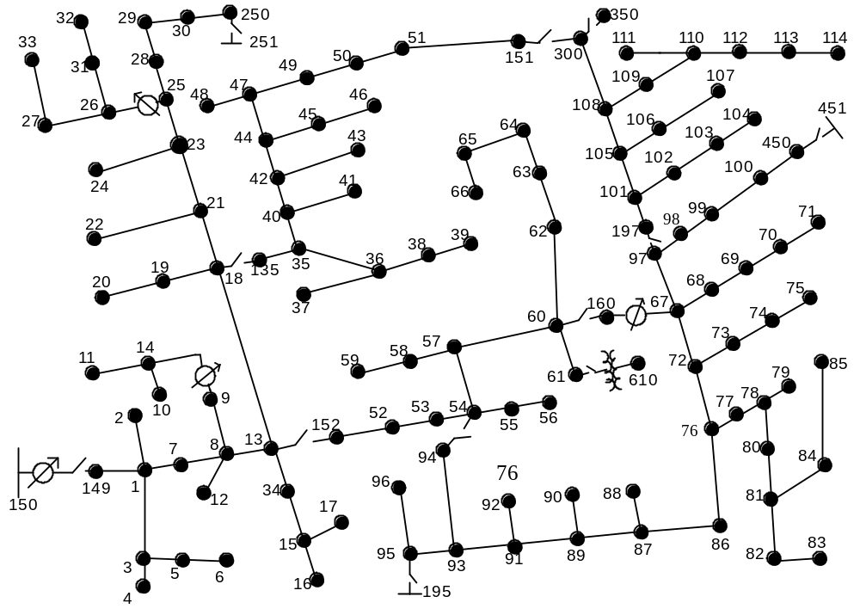

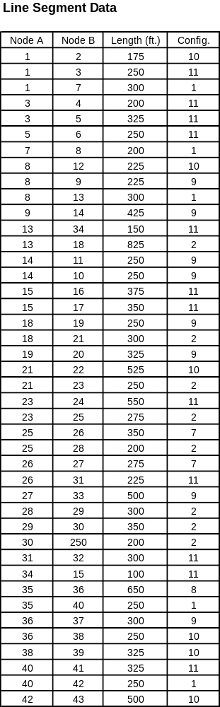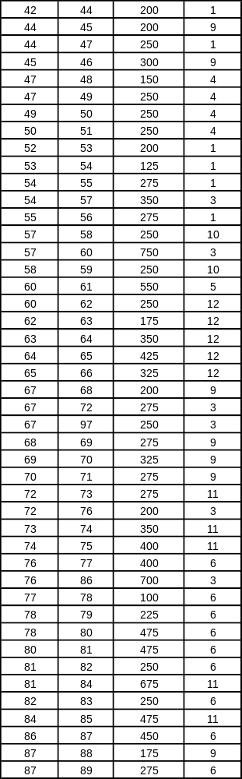

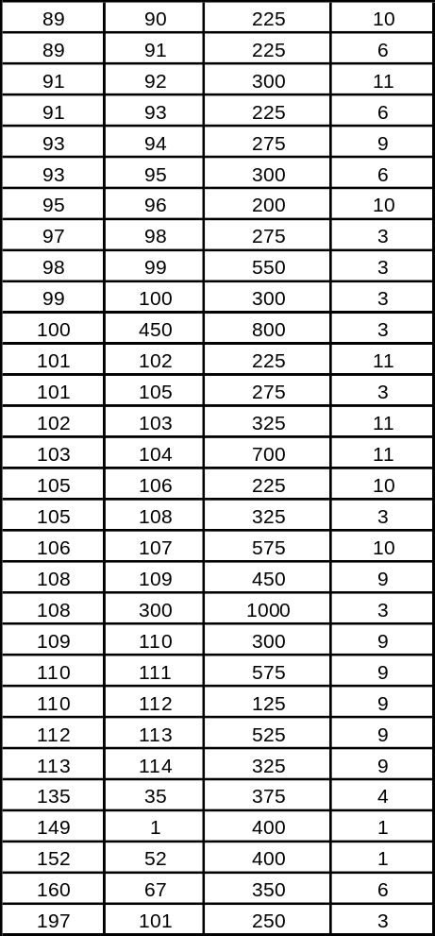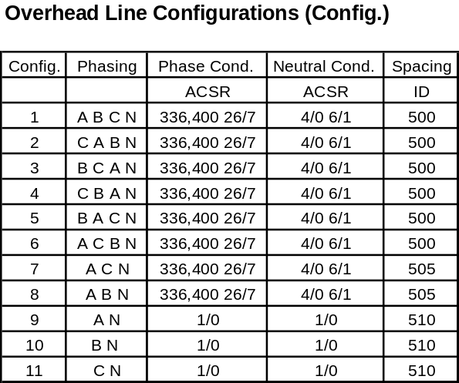Line Segment Data (cont.)

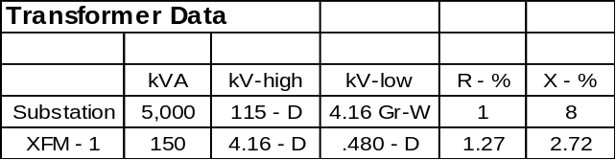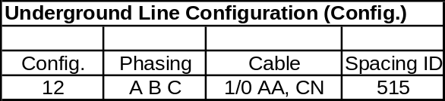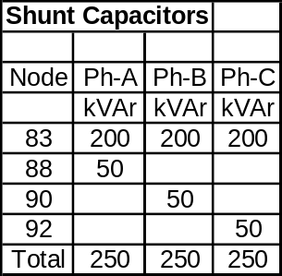
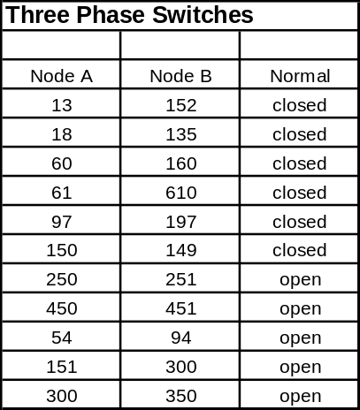

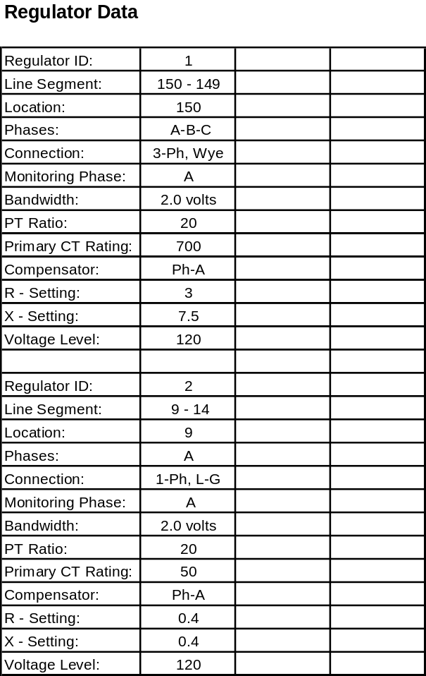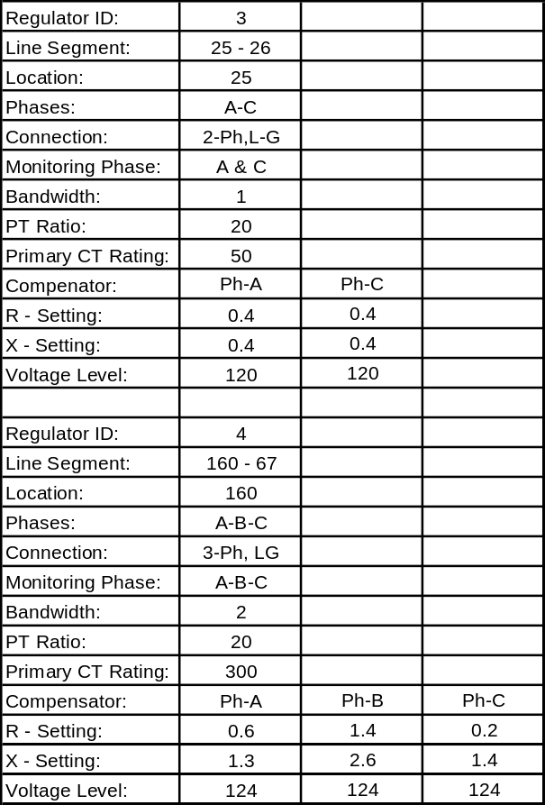

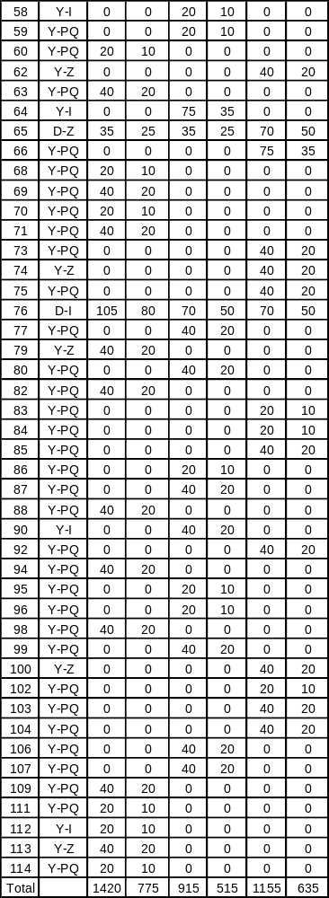
Spot Loads
Node
Load
Ph-1
Ph-1
Ph-2
Ph-2
Ph-3
Ph-4
Model
kW
kVAr
kW
kVAr
kW
kVAr
1
Y-PQ
40
20
0
0
0
0
2
Y-PQ
0
0
20
10
0
0
4
Y-PQ
0
0
0
0
40
20
5
Y-I
0
0
0
0
20
10
6
Y-Z
0
0
0
0
40
20
7
Y-PQ
20
10
0
0
0
0
9
Y-PQ
40
20
0
0
0
0
10
Y-I
20
10
0
0
0
0
11
Y-Z
40
20
0
0
0
0
12
Y-PQ
0
0
20
10
0
0
16
Y-PQ
0
0
0
0
40
20
17
Y-PQ
0
0
0
0
20
10
19
Y-PQ
40
20
0
0
0
0
20
Y-I
40
20
0
0
0
0
22
Y-Z
0
0
40
20
0
0
24
Y-PQ
0
0
0
0
40
20
28
Y-I
40
20
0
0
0
0
29
Y-Z
40
20
0
0
0
0
30
Y-PQ
0
0
0
0
40
20
31
Y-PQ
0
0
0
0
20
10
32
Y-PQ
0
0
0
0
20
10
33
Y-I
40
20
0
0
0
0
34
Y-Z
0
0
0
0
40
20
35
D-PQ
40
20
0
0
0
0
37
Y-Z
40
20
0
0
0
0
38
Y-I
0
0
20
10
0
0
39
Y-PQ
0
0
20
10
0
0
41
Y-PQ
0
0
0
0
20
10
42
Y-PQ
20
10
0
0
0
0
43
Y-Z
0
0
40
20
0
0
45
Y-I
20
10
0
0
0
0
46
Y-PQ
20
10
0
0
0
0
47
Y-I
35
25
35
25
35
25
48
Y-Z
70
50
70
50
70
50
49
Y-PQ
35
25
70
50
35
20
50
Y-PQ
0
0
0
0
40
20
51
Y-PQ
20
10
0
0
0
0
52
Y-PQ
40
20
0
0
0
0
53
Y-PQ
40
20
0
0
0
0
55
Y-Z
20
10
0
0
0
0
56
Y-PQ
0
0
20
10
0
0

IEEE 123 Node Test Feeder

Impedances

Configuration 1:

Z (R +jX) in ohms per mile
0.4576 1.0780 0.1560 0.5017 0.1535 0.3849
0.4666 1.0482 0.1580 0.4236
0.4615 1.0651
B in micro Siemens per mile
5.6765 -1.8319 -0.6982
5.9809 -1.1645
5.3971

Configuration 2:

Z (R +jX) in ohms per mile
0.4666 1.0482 0.1580 0.4236 0.1560 0.5017
0.4615 1.0651 0.1535 0.3849
0.4576 1.0780
B in micro Siemens per mile
5.9809 -1.1645 -1.8319
5.3971 -0.6982
5.6765

Configuration 3:

Z (R +jX) in ohms per mile
0.4615 1.0651 0.1535 0.3849 0.1580 0.4236
0.4576 1.0780 0.1560 0.5017
0.4666 1.0482
B in micro Siemens per mile
5.3971 -0.6982 -1.1645
5.6765 -1.8319
5.9809

Configuration 4:

Z (R +jX) in ohms per mile
0.4615 1.0651 0.1580 0.4236 0.1535 0.3849
0.4666 1.0482 0.1560 0.5017
0.4576 1.0780
B in micro Siemens per mile
5.3971 -1.1645 -0.6982
5.9809 -1.8319
5.6765

Configuration 5:

Z (R +jX) in ohms per mile
0.4666 1.0482 0.1560 0.5017 0.1580 0.4236
0.4576 1.0780 0.1535 0.3849
0.4615 1.0651
B in micro Siemens per mile
5.9809 -1.8319 -1.1645
5.6765 -0.6982
5.3971

Configuration 6:

Z (R +jX) in ohms per mile
0.4576 1.0780 0.1535 0.3849 0.1560 0.5017
0.4615 1.0651 0.1580 0.4236
0.4666 1.0482
B in micro Siemens per mile
5.6765 -0.6982 -1.8319
5.3971 -1.1645
5.9809

Configuration 7:

Z (R +jX) in ohms per mile
0.4576 1.0780 0.0000 0.0000 0.1535 0.3849
0.0000 0.0000 0.0000 0.0000
0.4615 1.0651
B in micro Siemens per mile
5.1154 0.0000 -1.0549
0.0000 0.0000
5.1704

Configuration 8:

Z (R +jX) in ohms per mile
0.4576 1.0780 0.1535 0.3849 0.0000 0.0000
0.4615 1.0651 0.0000 0.0000
0.0000 0.0000
B in micro Siemens per mile
5.1154 -1.0549 0.0000
5.1704 0.0000
0.0000

Configuration 9:

Z (R +jX) in ohms per mile
1.3292 1.3475 0.0000 0.0000 0.0000 0.0000
0.0000 0.0000 0.0000 0.0000
0.0000 0.0000
B in micro Siemens per mile
4.5193 0.0000 0.0000
0.0000 0.0000
0.0000

Configuration 10:

Z (R +jX) in ohms per mile
0.0000 0.0000 0.0000 0.0000 0.0000 0.0000
1.3292 1.3475 0.0000 0.0000
0.0000 0.0000
B in micro Siemens per mile
0.0000 0.0000 0.0000
4.5193 0.0000
0.0000

Configuration 11:

Z (R +jX) in ohms per mile
0.0000 0.0000 0.0000 0.0000 0.0000 0.0000
0.0000 0.0000 0.0000 0.0000
1.3292 1.3475
B in micro Siemens per mile
0.0000 0.0000 0.0000
0.0000 0.0000
4.5193

Configuration 12:

Z (R +jX) in ohms per mile
1.5209 0.7521 0.5198 0.2775 0.4924 0.2157
1.5329 0.7162 0.5198 0.2775
1.5209 0.7521
B in micro Siemens per mile
67.2242 0.0000 0.0000
67.2242 0.0000
67.2242
Power-Flow Results

- R A D I A L F L O W S U M M A R Y - DATE: 6-24-2004 AT 16:54:14 HOURS ---
SUBSTATION: IEEE 123; FEEDER: IEEE 123
-------------------------------------------------------------------------------
SYSTEM PHASE PHASE PHASE TOTAL
INPUT -------(A)-------|-------(B)-------|-------(C)-------|------------------
kW : 1463.861 | 963.484 | 1193.153 | 3620.498
kVAr : 582.101 | 343.687 | 398.976 | 1324.765
kVA : 1575.351 | 1022.947 | 1258.092 | 3855.257
PF : .9292 | .9419 | .9484 | .9391

LOAD --(A-N)----(A-B)-|--(B-N)----(B-C)-|--(C-N)----(C-A)-|---WYE-----DELTA--
kW : 1242.8 182.3| 822.8 108.1| 1026.3 142.6| 3091.9 433.0
TOT : 1425.022 | 930.965 | 1168.900 | 3524.887
| | |
kVAr : 651.0 126.7| 447.3 77.2| 535.9 101.8| 1634.3 305.8
TOT : 777.767 | 524.544 | 637.773 | 1940.083
| | |
kVA : 1403.0 222.0| 936.6 132.9| 1157.8 175.2| 3497.3 530.1
TOT : 1623.455 | 1068.570 | 1331.571 | 4023.524
| | |
PF : .8858 .8210| .8786 .8137| .8864 .8137| .8841 .8168
TOT : .8778 | .8712 | .8778 | .8761

LOSSES ------(A)-------|-------(B)-------|-------(C)-------|------------------
kW : 50.540 | 10.134 | 34.937 | 95.611
kVAr : 102.653 | 38.837 | 52.237 | 193.727
kVA : 114.420 | 40.137 | 62.844 | 216.036

CAPAC --(A-N)----(A-B)-|--(B-N)----(B-C)-|--(C-N)----(C-A)-|---WYE-----DELTA--
R-kVA: 250.0 .0| 250.0 .0| 250.0 .0| 750.0 .0
TOT : 250.000 | 250.000 | 250.000 | 750.000
| | |
A-kVA: 271.3 .0| 268.0 .0| 269.7 .0| 809.0 .0
TOT : 271.290 | 268.023 | 269.733 | 809.046

--- V O L T A G E P R O F I L E ---- DATE: 6-24-2004 AT 16:54:32 HOURS ----
SUBSTATION: IEEE 123; FEEDER: IEEE 123
-------------------------------------------------------------------------------
NODE | MAG ANGLE | MAG ANGLE | MAG ANGLE |mi.to SR
-------------------------------------------------------------------------------
______|_______ A-N ______ |_______ B-N _______ |_______ C-N _______ |
150 | 1.0000 at .00 | 1.0000 at -120.00 | 1.0000 at 120.00 | .000
RG1 | 1.0437 at .00 | 1.0438 at -120.00 | 1.0438 at 120.00 | .000
149 | 1.0436 at -.02 | 1.0437 at -120.02 | 1.0436 at 119.98 | .000
1 | 1.0311 at -.66 | 1.0412 at -120.33 | 1.0348 at 119.60 | .076
2 | | 1.0410 at -120.33 | | .109
3 | | | 1.0331 at 119.57 | .123
4 | | | 1.0326 at 119.56 | .161
5 | | | 1.0318 at 119.55 | .185
6 | | | 1.0311 at 119.53 | .232
7 | 1.0218 at -1.13 | 1.0395 at -120.57 | 1.0291 at 119.35 | .133
8 | 1.0158 at -1.44 | 1.0382 at -120.74 | 1.0253 at 119.18 | .171
12 | | 1.0379 at -120.74 | | .213
13 | 1.0079 at -1.87 | 1.0360 at -120.97 | 1.0196 at 118.90 | .227
152 | 1.0078 at -1.88 | 1.0360 at -120.98 | 1.0196 at 118.89 | .227
52 | 1.0018 at -2.26 | 1.0348 at -121.22 | 1.0164 at 118.64 | .303
53 | .9991 at -2.43 | 1.0340 at -121.34 | 1.0148 at 118.51 | .341
54 | .9976 at -2.53 | 1.0334 at -121.41 | 1.0138 at 118.43 | .365
55 | .9974 at -2.54 | 1.0334 at -121.42 | 1.0139 at 118.43 | .417
56 | .9974 at -2.53 | 1.0332 at -121.43 | 1.0140 at 118.43 | .469
57 | .9945 at -2.83 | 1.0306 at -121.61 | 1.0113 at 118.21 | .431
58 | | 1.0300 at -121.63 | | .478
59 | | 1.0296 at -121.63 | | .526
60 | .9880 at -3.51 | 1.0256 at -122.00 | 1.0052 at 117.76 | .573
160 | .9880 at -3.52 | 1.0256 at -122.01 | 1.0052 at 117.75 | .573
RG4 | 1.0374 at -3.52 | 1.0320 at -122.01 | 1.0366 at 117.75 | .573
67 | 1.0355 at -3.77 | 1.0311 at -122.19 | 1.0345 at 117.61 | .640
68 | 1.0340 at -3.79 | | | .677
69 | 1.0322 at -3.83 | | | .730
70 | 1.0310 at -3.85 | | | .791
71 | 1.0303 at -3.86 | | | .843
72 | 1.0359 at -3.86 | 1.0302 at -122.29 | 1.0343 at 117.50 | .692
73 | | | 1.0321 at 117.46 | .744
74 | | | 1.0303 at 117.42 | .810
75 | | | 1.0293 at 117.40 | .886
76 | 1.0358 at -3.92 | 1.0297 at -122.38 | 1.0349 at 117.45 | .730
77 | 1.0370 at -3.99 | 1.0308 at -122.46 | 1.0358 at 117.37 | .805
78 | 1.0373 at -4.01 | 1.0312 at -122.48 | 1.0360 at 117.35 | .824
79 | 1.0370 at -4.02 | 1.0313 at -122.48 | 1.0359 at 117.36 | .867
80 | 1.0394 at -4.07 | 1.0329 at -122.54 | 1.0368 at 117.24 | .914
81 | 1.0415 at -4.14 | 1.0352 at -122.57 | 1.0374 at 117.14 | 1.004
82 | 1.0424 at -4.18 | 1.0364 at -122.60 | 1.0382 at 117.11 | 1.052
83 | 1.0436 at -4.20 | 1.0375 at -122.63 | 1.0390 at 117.07 | 1.099
84 | | | 1.0348 at 117.09 | 1.132
85 | | | 1.0336 at 117.07 | 1.222
86 | 1.0349 at -3.95 | 1.0279 at -122.55 | 1.0364 at 117.42 | .862
87 | 1.0342 at -3.97 | 1.0272 at -122.63 | 1.0369 at 117.39 | .947
88 | 1.0342 at -4.00 | | | .980
89 | 1.0338 at -3.96 | 1.0270 at -122.68 | 1.0373 at 117.38 | .999
90 | | 1.0269 at -122.72 | | 1.042

--- V O L T A G E P R O F I L E ---- DATE: 6-24-2004 AT 16:54:32 HOURS ----
SUBSTATION: IEEE 123; FEEDER: IEEE 123
-------------------------------------------------------------------------------
NODE | MAG ANGLE | MAG ANGLE | MAG ANGLE |mi.to SR
-------------------------------------------------------------------------------
91 | 1.0336 at -3.96 | 1.0266 at -122.69 | 1.0376 at 117.36 | 1.042
92 | | | 1.0375 at 117.31 | 1.099
93 | 1.0333 at -3.97 | 1.0265 at -122.71 | 1.0377 at 117.37 | 1.085
94 | 1.0326 at -3.98 | | | 1.137
95 | 1.0332 at -3.96 | 1.0261 at -122.73 | 1.0378 at 117.37 | 1.141
96 | | 1.0258 at -122.73 | | 1.179
97 | 1.0345 at -3.82 | 1.0306 at -122.21 | 1.0338 at 117.60 | .687
197 | 1.0345 at -3.82 | 1.0306 at -122.21 | 1.0338 at 117.59 | .687
101 | 1.0337 at -3.86 | 1.0303 at -122.22 | 1.0332 at 117.59 | .734
102 | | | 1.0318 at 117.56 | .777
103 | | | 1.0301 at 117.53 | .838
104 | | | 1.0283 at 117.49 | .971
105 | 1.0323 at -3.90 | 1.0301 at -122.27 | 1.0335 at 117.61 | .786
106 | | 1.0290 at -122.29 | | .829
107 | | 1.0275 at -122.32 | | .938
108 | 1.0309 at -3.97 | 1.0308 at -122.28 | 1.0334 at 117.65 | .848
109 | 1.0267 at -4.05 | | | .933
110 | 1.0248 at -4.09 | | | .990
111 | 1.0240 at -4.10 | | | 1.099
112 | 1.0241 at -4.10 | | | 1.014
113 | 1.0220 at -4.14 | | | 1.113
114 | 1.0216 at -4.15 | | | 1.175
300 | 1.0309 at -3.97 | 1.0308 at -122.28 | 1.0334 at 117.65 | 1.037
98 | 1.0343 at -3.83 | 1.0303 at -122.22 | 1.0336 at 117.59 | .739
99 | 1.0346 at -3.82 | 1.0295 at -122.23 | 1.0332 at 117.55 | .843
100 | 1.0348 at -3.82 | 1.0294 at -122.21 | 1.0328 at 117.53 | .900
450 | 1.0348 at -3.82 | 1.0294 at -122.21 | 1.0328 at 117.53 | 1.052
61 | .9880 at -3.51 | 1.0256 at -122.00 | 1.0052 at 117.76 | .677
XF1 | .9880 at -3.51 | 1.0256 at -122.00 | 1.0052 at 117.76 | .677
610 | .9880 at -3.51 | 1.0256 at -122.00 | 1.0052 at 117.76 | .677
62 | .9872 at -3.50 | 1.0245 at -121.98 | 1.0032 at 117.75 | .620
63 | .9866 at -3.49 | 1.0236 at -121.97 | 1.0022 at 117.74 | .654
64 | .9863 at -3.47 | 1.0217 at -121.93 | 1.0000 at 117.70 | .720
65 | .9856 at -3.48 | 1.0214 at -121.89 | .9970 at 117.70 | .800
66 | .9858 at -3.51 | 1.0216 at -121.87 | .9955 at 117.70 | .862
18 | .9988 at -2.29 | 1.0319 at -121.22 | 1.0122 at 118.83 | .384
135 | .9988 at -2.29 | 1.0318 at -121.23 | 1.0122 at 118.83 | .384
35 | .9960 at -2.38 | 1.0293 at -121.31 | 1.0112 at 118.77 | .455
36 | .9951 at -2.40 | 1.0288 at -121.36 | | .578
37 | .9943 at -2.41 | | | .635
38 | | 1.0282 at -121.37 | | .625
39 | | 1.0278 at -121.38 | | .687
40 | .9945 at -2.42 | 1.0282 at -121.36 | 1.0101 at 118.72 | .502
41 | | | 1.0097 at 118.71 | .564
42 | .9929 at -2.45 | 1.0270 at -121.41 | 1.0092 at 118.68 | .549
43 | | 1.0257 at -121.43 | | .644
44 | .9918 at -2.48 | 1.0263 at -121.44 | 1.0084 at 118.65 | .587

--- V O L T A G E P R O F I L E ---- DATE: 6-24-2004 AT 16:54:32 HOURS ----
SUBSTATION: IEEE 123; FEEDER: IEEE 123
-------------------------------------------------------------------------------
NODE | MAG ANGLE | MAG ANGLE | MAG ANGLE |mi.to SR
-------------------------------------------------------------------------------
45 | .9913 at -2.49 | | | .625
46 | .9909 at -2.50 | | | .682
47 | .9908 at -2.50 | 1.0253 at -121.47 | 1.0074 at 118.61 | .635
48 | .9905 at -2.51 | 1.0250 at -121.47 | 1.0072 at 118.60 | .663
49 | .9905 at -2.51 | 1.0247 at -121.48 | 1.0071 at 118.58 | .682
50 | .9905 at -2.52 | 1.0247 at -121.47 | 1.0067 at 118.57 | .729
51 | .9903 at -2.53 | 1.0248 at -121.47 | 1.0067 at 118.58 | .777
151 | .9903 at -2.53 | 1.0248 at -121.47 | 1.0067 at 118.58 | .871
19 | .9975 at -2.31 | | | .431
20 | .9967 at -2.33 | | | .493
21 | .9983 at -2.34 | 1.0320 at -121.22 | 1.0111 at 118.81 | .441
22 | | 1.0305 at -121.25 | | .540
23 | .9979 at -2.39 | 1.0323 at -121.20 | 1.0100 at 118.79 | .488
24 | | | 1.0085 at 118.77 | .592
25 | .9972 at -2.45 | 1.0328 at -121.20 | 1.0091 at 118.80 | .540
28 | .9968 at -2.48 | 1.0330 at -121.19 | 1.0087 at 118.80 | .578
29 | .9967 at -2.50 | 1.0332 at -121.19 | 1.0083 at 118.79 | .635
30 | .9969 at -2.50 | 1.0331 at -121.18 | 1.0078 at 118.77 | .701
250 | .9969 at -2.50 | 1.0331 at -121.18 | 1.0078 at 118.77 | .739
RG3 | .9972 at -2.45 | | 1.0028 at 118.80 | .540
26 | .9970 at -2.48 | | 1.0023 at 118.79 | .606
27 | .9966 at -2.49 | | 1.0022 at 118.79 | .659
33 | .9953 at -2.52 | | | .753
31 | | | 1.0017 at 118.77 | .649
32 | | | 1.0013 at 118.77 | .706
34 | | | 1.0187 at 118.88 | .256
15 | | | 1.0183 at 118.87 | .275
16 | | | 1.0173 at 118.85 | .346
17 | | | 1.0178 at 118.86 | .341
9 | 1.0144 at -1.47 | | | .213
RG2 | 1.0080 at -1.47 | | | .213
14 | 1.0063 at -1.50 | | | .294
10 | 1.0060 at -1.50 | | | .341
11 | 1.0057 at -1.51 | | | .341

----------- VOLTAGE REGULATOR DATA ---- DATE: 6-24-2004 AT 16:54:35 HOURS --
SUBSTATION: IEEE 123; FEEDER: IEEE 123
_______________________________________________________________________________
[NODE]--[VREG]-----[SEG]------[NODE] MODEL OPT BNDW
150 RG1 149 149 Phase A, 3 Phase Ganged Wye RX 2.00
........................................................................
PHASE LDCTR VOLT HOLD R-VOLT X-VOLT PT RATIO CT RATE TAP
1 120.000 3.000 7.500 20.00 700.00 7
_______________________________________________________________________________
[NODE]--[VREG]-----[SEG]------[NODE] MODEL OPT BNDW
160 RG4 67 67 Phase A & B & C, Wye RX 2.00
........................................................................
PHASE LDCTR VOLT HOLD R-VOLT X-VOLT PT RATIO CT RATE TAP
1 124.000 .600 1.300 20.00 300.00 8
2 124.000 1.400 2.600 20.00 300.00 1
3 124.000 .200 1.400 20.00 300.00 5
_______________________________________________________________________________
[NODE]--[VREG]-----[SEG]------[NODE] MODEL OPT BNDW
25 RG3 26 26 Phase A & C, Wye RX 1.00
........................................................................
PHASE LDCTR VOLT HOLD R-VOLT X-VOLT PT RATIO CT RATE TAP
1 120.000 .400 .400 20.00 50.00 0
3 120.000 .400 .400 20.00 50.00 -1
_______________________________________________________________________________
[NODE]--[VREG]-----[SEG]------[NODE] MODEL OPT BNDW
9 RG2 14 14 Phase A, Wye RX 2.00
........................................................................
PHASE LDCTR VOLT HOLD R-VOLT X-VOLT PT RATIO CT RATE TAP
1 120.000 .400 .400 20.00 50.00 -1

- R A D I A L P O W E R F L O W --- DATE: 6-24-2004 AT 16:54:45 HOURS ---
SUBSTATION: IEEE 123; FEEDER: IEEE 123
-------------------------------------------------------------------------------
NODE VALUE PHASE A PHASE B PHASE C UNT O/L<
(LINE A) (LINE B) (LINE C) 60.%
---------------------*--------A-------*-------B-------*-------C-------*--------
NODE: 150 VOLTS: 1.000 .00 1.000 -120.00 1.000 120.00 MAG/ANG
kVll 4.160 NO LOAD OR CAPACITOR REPRESENTED AT SOURCE NODE

TO NODE RG1 <VRG>..: 655.91 -21.69 425.91 -139.63 523.82 101.51 AMP/DG <
<RG1 > LOSS= .000: ( .000) ( .000) ( .000) kW
---------------------*--------A-------*-------B-------*-------C-------*--------
NODE: RG1 VOLTS: 1.044 .00 1.044 -120.00 1.044 120.00 MAG/ANG
-LD: .00 .00 .00 .00 .00 .00 kW/kVR
kVll 4.160 CAP: .00 .00 .00 kVR

FROM NODE 150 <VRG>: 628.42 -21.69 408.06 -139.63 501.86 101.51 AMP/DG <
<RG1 > LOSS= .000: ( .000) ( .000) ( .000) kW
TO NODE 149 .......: 628.42 -21.69 408.06 -139.63 501.86 101.51 AMP/DG <
<149 > LOSS= .000: ( .000) ( .000) ( .000) kW
---------------------*--------A-------*-------B-------*-------C-------*--------
NODE: 149 VOLTS: 1.044 -.02 1.044 -120.02 1.044 119.98 MAG/ANG
-LD: .00 .00 .00 .00 .00 .00 kW/kVR
kVll 4.160 CAP: .00 .00 .00 kVR

FROM NODE RG1 .....: 628.42 -21.69 408.06 -139.63 501.86 101.51 AMP/DG <
<149 > LOSS= .000: ( .000) ( .000) ( .000) kW
TO NODE 1 .......: 628.42 -21.69 408.06 -139.63 501.86 101.51 AMP/DG <
<1 > LOSS= 19.159: ( 11.176) ( .429) ( 7.554) kW
---------------------*--------A-------*-------B-------*-------C-------*--------
NODE: 1 VOLTS: 1.031 -.66 1.041 -120.33 1.035 119.60 MAG/ANG
Y-LD: 40.00 20.00 .00 .00 .00 .00 kW/kVR
kVll 4.160 Y CAP: .00 .00 .00 kVR

FROM NODE 149 .....: 628.42 -21.69 408.06 -139.63 501.86 101.51 AMP/DG <
<1 > LOSS= 19.159: ( 11.176) ( .429) ( 7.554) kW
TO NODE 2 .......: 8.94 -146.89 AMP/DG
<2 > LOSS= .004: ( .004) kW
TO NODE 3 .......: 46.54 92.99 AMP/DG
<3 > LOSS= .136: ( .136) kW
TO NODE 7 .......: 610.45 -21.52 399.19 -139.47 455.89 102.38 AMP/DG <
<7 > LOSS= 13.090: ( 8.408) ( .167) ( 4.515) kW
---------------------*--------A-------*-------B-------*-------C-------*--------
NODE: 2 VOLTS: 1.041 -120.33 MAG/ANG
Y-LD: 20.00 10.00 kW/kVR
kVll 4.160 Y CAP: .00 kVR

FROM NODE 1 .....: 8.94 -146.89 AMP/DG
<2 > LOSS= .004: ( .004) kW

- R A D I A L P O W E R F L O W --- DATE: 6-24-2004 AT 16:54:45 HOURS ---
SUBSTATION: IEEE 123; FEEDER: IEEE 123
-------------------------------------------------------------------------------
NODE VALUE PHASE A PHASE B PHASE C UNT O/L<
(LINE A) (LINE B) (LINE C) 60.%
---------------------*--------A-------*-------B-------*-------C-------*--------
NODE: 3 VOLTS: 1.033 119.57 MAG/ANG
-LD: .00 .00 kW/kVR
kVLL 4.160 CAP: .00 kVR

FROM NODE 1 .....: 46.54 92.98 AMP/DG
<3 > LOSS= .136: ( .136) kW
TO NODE 4 .......: 18.03 93.00 AMP/DG
<4 > LOSS= .016: ( .016) kW
TO NODE 5 .......: 28.51 92.98 AMP/DG
<5 > LOSS= .066: ( .066) kW
---------------------*--------A-------*-------B-------*-------C-------*--------
NODE: 4 VOLTS: 1.033 119.56 MAG/ANG
Y-LD: 40.00 20.00 kW/kVR
kVLL 4.160 Y CAP: .00 kVR

FROM NODE 3 .....: 18.03 93.00 AMP/DG
<4 > LOSS= .016: ( .016) kW
---------------------*--------A-------*-------B-------*-------C-------*--------
NODE: 5 VOLTS: 1.032 119.55 MAG/ANG
Y-LD: 20.64 10.32 kW/kVR
kVLL 4.160 Y CAP: .00 kVR

FROM NODE 3 .....: 28.51 92.97 AMP/DG
<5 > LOSS= .066: ( .066) kW
TO NODE 6 .......: 19.20 92.97 AMP/DG
<6 > LOSS= .023: ( .023) kW
---------------------*--------A-------*-------B-------*-------C-------*--------
NODE: 6 VOLTS: 1.031 119.53 MAG/ANG
Y-LD: 42.53 21.27 kW/kVR
kVLL 4.160 Y CAP: .00 kVR

FROM NODE 5 .....: 19.20 92.97 AMP/DG
<6 > LOSS= .023: ( .023) kW
---------------------*--------A-------*-------B-------*-------C-------*--------
NODE: 7 VOLTS: 1.022 -1.13 1.039 -120.57 1.029 119.35 MAG/ANG
Y-LD: 20.00 10.00 .00 .00 .00 .00 kW/kVR
kVll 4.160 Y CAP: .00 .00 .00 kVR

FROM NODE 1 .....: 610.45 -21.52 399.19 -139.47 455.89 102.38 AMP/DG <
<7 > LOSS= 13.090: ( 8.408) ( .167) ( 4.515) kW
TO NODE 8 .......: 601.39 -21.43 399.19 -139.47 455.89 102.38 AMP/DG <
<8 > LOSS= 8.583: ( 5.420) ( .184) ( 2.979) kW

- R A D I A L P O W E R F L O W --- DATE: 6-24-2004 AT 16:54:45 HOURS ---
SUBSTATION: IEEE 123; FEEDER: IEEE 123
-------------------------------------------------------------------------------
NODE VALUE PHASE A PHASE B PHASE C UNT O/L<
(LINE A) (LINE B) (LINE C) 60.%
---------------------*--------A-------*-------B-------*-------C-------*--------
NODE: 8 VOLTS: 1.016 -1.44 1.038 -120.74 1.025 119.18 MAG/ANG
-LD: .00 .00 .00 .00 .00 .00 kW/kVR
kVll 4.160 CAP: .00 .00 .00 kVR

FROM NODE 7 .....: 601.39 -21.43 399.19 -139.47 455.89 102.38 AMP/DG <
<8 > LOSS= 8.583: ( 5.420) ( .184) ( 2.979) kW
TO NODE 12 .......: 8.97 -147.31 AMP/DG
<12 > LOSS= .005: ( .005) kW
TO NODE 13 .......: 555.51 -20.88 390.31 -139.29 455.89 102.38 AMP/DG <
<13 > LOSS= 11.745: ( 6.704) ( .700) ( 4.341) kW
TO NODE 9 .......: 46.22 -28.05 AMP/DG
<9 > LOSS= .122: ( .122) kW
---------------------*--------A-------*-------B-------*-------C-------*--------
NODE: 12 VOLTS: 1.038 -120.74 MAG/ANG
Y-LD: 20.00 10.00 kW/kVR
kVll 4.160 Y CAP: .00 kVR

FROM NODE 8 .....: 8.97 -147.31 AMP/DG
<12 > LOSS= .005: ( .005) kW
---------------------*--------A-------*-------B-------*-------C-------*--------
NODE: 13 VOLTS: 1.008 -1.87 1.036 -120.97 1.020 118.90 MAG/ANG
-LD: .00 .00 .00 .00 .00 .00 kW/kVR
kVll 4.160 CAP: .00 .00 .00 kVR

FROM NODE 8 .....: 555.51 -20.88 390.31 -139.29 455.89 102.38 AMP/DG <
<13 > LOSS= 11.745: ( 6.704) ( .700) ( 4.341) kW
TO NODE 152 .......: 332.01 -14.31 244.34 -129.30 265.02 112.07 AMP/DG
<152 > LOSS= .000: ( .000) ( .000) ( .000) kW
TO NODE 18 .......: 228.85 -30.43 155.56 -155.10 153.35 88.61 AMP/DG
<18 > LOSS= 4.907: ( 2.436) ( .341) ( 2.131) kW
TO NODE 34 .......: 46.42 92.30 AMP/DG
<34 > LOSS= .081: ( .081) kW
---------------------*--------A-------*-------B-------*-------C-------*--------
NODE: 152 VOLTS: 1.008 -1.88 1.036 -120.98 1.020 118.89 MAG/ANG
-LD: .00 .00 .00 .00 .00 .00 kW/kVR
kVll 4.160 CAP: .00 .00 .00 kVR

FROM NODE 13 .....: 332.01 -14.31 244.34 -129.30 265.02 112.07 AMP/DG
<152 > LOSS= .000: ( .000) ( .000) ( .000) kW
TO NODE 52 .......: 332.01 -14.31 244.34 -129.30 265.02 112.07 AMP/DG <
<52 > LOSS= 5.621: ( 3.538) ( .363) ( 1.719) kW

- R A D I A L P O W E R F L O W --- DATE: 6-24-2004 AT 16:54:45 HOURS ---
SUBSTATION: IEEE 123; FEEDER: IEEE 123
-------------------------------------------------------------------------------
NODE VALUE PHASE A PHASE B PHASE C UNT O/L<
(LINE A) (LINE B) (LINE C) 60.%
---------------------*--------A-------*-------B-------*-------C-------*--------
NODE: 52 VOLTS: 1.002 -2.26 1.035 -121.22 1.016 118.64 MAG/ANG
Y-LD: 40.00 20.00 .00 .00 .00 .00 kW/kVR
kVll 4.160 Y CAP: .00 .00 .00 kVR

FROM NODE 152 .....: 332.01 -14.31 244.34 -129.30 265.02 112.07 AMP/DG <
<52 > LOSS= 5.621: ( 3.538) ( .363) ( 1.719) kW
TO NODE 53 .......: 314.05 -13.46 244.34 -129.30 265.02 112.07 AMP/DG
<53 > LOSS= 2.663: ( 1.555) ( .271) ( .837) kW
---------------------*--------A-------*-------B-------*-------C-------*--------
NODE: 53 VOLTS: .999 -2.43 1.034 -121.34 1.015 118.51 MAG/ANG
Y-LD: 40.00 20.00 .00 .00 .00 .00 kW/kVR
kVll 4.160 Y CAP: .00 .00 .00 kVR

FROM NODE 52 .....: 314.05 -13.46 244.34 -129.30 265.02 112.07 AMP/DG
<53 > LOSS= 2.663: ( 1.555) ( .271) ( .837) kW
TO NODE 54 .......: 296.14 -12.50 244.34 -129.30 265.02 112.07 AMP/DG
<54 > LOSS= 1.580: ( .846) ( .226) ( .508) kW
---------------------*--------A-------*-------B-------*-------C-------*--------
NODE: 54 VOLTS: .998 -2.53 1.033 -121.41 1.014 118.43 MAG/ANG
-LD: .00 .00 .00 .00 .00 .00 kW/kVR
kVll 4.160 CAP: .00 .00 .00 kVR

FROM NODE 53 .....: 296.14 -12.50 244.34 -129.30 265.02 112.07 AMP/DG
<54 > LOSS= 1.580: ( .846) ( .226) ( .508) kW
TO NODE 55 .......: 9.28 -29.09 9.01 -147.98 .00 .00 AMP/DG
<55 > LOSS= .003: ( .003) ( .000) ( .000) kW
TO NODE 57 .......: 287.25 -11.97 235.82 -128.60 265.02 112.07 AMP/DG
<57 > LOSS= 4.240: ( 1.543) ( 1.328) ( 1.369) kW
---------------------*--------A-------*-------B-------*-------C-------*--------
NODE: 55 VOLTS: .997 -2.54 1.033 -121.42 1.014 118.43 MAG/ANG
Y-LD: 19.90 9.95 .00 .00 .00 .00 kW/kVR
kVll 4.160 Y CAP: .00 .00 .00 kVR

FROM NODE 54 .....: 9.29 -29.10 9.01 -147.99 .00 .00 AMP/DG
<55 > LOSS= .003: ( .003) ( .000) ( .000) kW
TO NODE 56 .......: .00 .00 9.01 -147.99 .00 .00 AMP/DG
<56 > LOSS= .002: ( .000) ( .002) ( .000) kW
---------------------*--------A-------*-------B-------*-------C-------*--------
NODE: 56 VOLTS: .997 -2.53 1.033 -121.43 1.014 118.43 MAG/ANG
Y-LD: .00 .00 20.00 10.00 .00 .00 kW/kVR
kVll 4.160 Y CAP: .00 .00 .00 kVR

FROM NODE 55 .....: .00 .00 9.01 -147.99 .00 .00 AMP/DG
<56 > LOSS= .002: ( .000) ( .002) ( .000) kW

- R A D I A L P O W E R F L O W --- DATE: 6-24-2004 AT 16:54:45 HOURS ---
SUBSTATION: IEEE 123; FEEDER: IEEE 123
-------------------------------------------------------------------------------
NODE VALUE PHASE A PHASE B PHASE C UNT O/L<
(LINE A) (LINE B) (LINE C) 60.%
---------------------*--------A-------*-------B-------*-------C-------*--------
NODE: 57 VOLTS: .994 -2.83 1.031 -121.61 1.011 118.21 MAG/ANG
-LD: .00 .00 .00 .00 .00 .00 kW/kVR
kVll 4.160 CAP: .00 .00 .00 kVR

FROM NODE 54 .....: 287.25 -11.97 235.82 -128.60 265.02 112.07 AMP/DG
<57 > LOSS= 4.240: ( 1.543) ( 1.328) ( 1.369) kW
TO NODE 58 .......: 18.35 -148.19 AMP/DG
<58 > LOSS= .021: ( .021) kW
TO NODE 60 .......: 287.25 -11.97 218.62 -126.99 265.02 112.07 AMP/DG
<60 > LOSS= 8.780: ( 3.190) ( 2.296) ( 3.294) kW
---------------------*--------A-------*-------B-------*-------C-------*--------
NODE: 58 VOLTS: 1.030 -121.63 MAG/ANG
Y-LD: 20.60 10.30 kW/kVR
kVll 4.160 Y CAP: .00 kVR

FROM NODE 57 .....: 18.35 -148.19 AMP/DG
<58 > LOSS= .021: ( .021) kW
TO NODE 59 .......: 9.04 -148.19 AMP/DG
<59 > LOSS= .005: ( .005) kW
---------------------*--------A-------*-------B-------*-------C-------*--------
NODE: 59 VOLTS: 1.030 -121.63 MAG/ANG
Y-LD: 20.00 10.00 kW/kVR
kVll 4.160 Y CAP: .00 kVR

FROM NODE 58 .....: 9.04 -148.20 AMP/DG
<59 > LOSS= .005: ( .005) kW
---------------------*--------A-------*-------B-------*-------C-------*--------
NODE: 60 VOLTS: .988 -3.51 1.026 -122.00 1.005 117.76 MAG/ANG
Y-LD: 20.00 10.00 .00 .00 .00 .00 kW/kVR
kVll 4.160 Y CAP: .00 .00 .00 kVR

FROM NODE 57 .....: 287.25 -11.97 218.62 -126.99 265.02 112.07 AMP/DG
<60 > LOSS= 8.780: ( 3.190) ( 2.296) ( 3.294) kW
TO NODE 160 .......: 240.09 -5.95 172.00 -120.02 191.06 120.31 AMP/DG
<160 > LOSS= .000: ( .000) ( .000) ( .000) kW
TO NODE 61 .......: .00 .00 .00 .00 .00 .00 AMP/DG
<61 > LOSS= .000: ( .000) ( .001) ( .000) kW
TO NODE 62 .......: 45.37 -41.35 52.24 -150.54 80.73 92.22 AMP/DG
<62 > LOSS= .565: ( .072) ( .151) ( .341) kW
---------------------*--------A-------*-------B-------*-------C-------*--------
NODE: 160 VOLTS: .988 -3.52 1.026 -122.01 1.005 117.75 MAG/ANG
-LD: .00 .00 .00 .00 .00 .00 kW/kVR
kVll 4.160 CAP: .00 .00 .00 kVR

FROM NODE 60 .....: 240.09 -5.95 172.00 -120.02 191.06 120.31 AMP/DG
<160 > LOSS= .000: ( .000) ( .000) ( .000) kW
TO NODE RG4 .<VRG>.: 240.09 -5.95 172.00 -120.02 191.06 120.31 AMP/DG <
<RG4 > LOSS= .000: ( .000) ( .000) ( .000) kW

- R A D I A L P O W E R F L O W --- DATE: 6-24-2004 AT 16:54:45 HOURS ---
SUBSTATION: IEEE 123; FEEDER: IEEE 123
-------------------------------------------------------------------------------
NODE VALUE PHASE A PHASE B PHASE C UNT O/L<
(LINE A) (LINE B) (LINE C) 60.%
---------------------*--------A-------*-------B-------*-------C-------*--------
NODE: RG4 VOLTS: 1.037 -3.52 1.032 -122.01 1.037 117.75 MAG/ANG
-LD: .00 .00 .00 .00 .00 .00 kW/kVR
kVll 4.160 CAP: .00 .00 .00 kVR

FROM NODE 160 <VRG>: 228.66 -5.95 170.93 -120.02 185.27 120.31 AMP/DG
<RG4 > LOSS= .000: ( .000) ( .000) ( .000) kW
TO NODE 67 .......: 228.66 -5.95 170.93 -120.02 185.27 120.31 AMP/DG
<67 > LOSS= 2.371: ( .940) ( .429) ( 1.001) kW
---------------------*--------A-------*-------B-------*-------C-------*--------
NODE: 67 VOLTS: 1.036 -3.77 1.031 -122.19 1.035 117.61 MAG/ANG
-LD: .00 .00 .00 .00 .00 .00 kW/kVR
kVll 4.160 CAP: .00 .00 .00 kVR

FROM NODE RG4 .....: 228.66 -5.95 170.93 -120.02 185.27 120.31 AMP/DG
<67 > LOSS= 2.371: ( .940) ( .429) ( 1.001) kW
TO NODE 68 .......: 54.15 -30.40 AMP/DG
<68 > LOSS= .148: ( .148) kW
TO NODE 72 .......: 118.75 22.68 126.10 -108.04 132.91 134.06 AMP/DG
<72 > LOSS= .769: ( .117) ( .396) ( .256) kW
TO NODE 97 .......: 82.68 -30.60 54.30 -148.83 64.43 90.97 AMP/DG
<97 > LOSS= .206: ( .094) ( .035) ( .077) kW
---------------------*--------A-------*-------B-------*-------C-------*--------
NODE: 68 VOLTS: 1.034 -3.79 MAG/ANG
Y-LD: 20.00 10.00 kW/kVR
kVll 4.160 Y CAP: .00 kVR

FROM NODE 67 .....: 54.15 -30.40 AMP/DG
<68 > LOSS= .148: ( .148) kW
TO NODE 69 .......: 45.14 -30.41 AMP/DG
<69 > LOSS= .141: ( .141) kW
---------------------*--------A-------*-------B-------*-------C-------*--------
NODE: 69 VOLTS: 1.032 -3.83 MAG/ANG
Y-LD: 40.00 20.00 kW/kVR
kVll 4.160 Y CAP: .00 kVR

FROM NODE 68 .....: 45.14 -30.41 AMP/DG
<69 > LOSS= .141: ( .141) kW
TO NODE 70 .......: 27.10 -30.42 AMP/DG
<70 > LOSS= .060: ( .060) kW
---------------------*--------A-------*-------B-------*-------C-------*--------
NODE: 70 VOLTS: 1.031 -3.85 MAG/ANG
Y-LD: 20.00 10.00 kW/kVR
kVll 4.160 Y CAP: .00 kVR

FROM NODE 69 .....: 27.10 -30.42 AMP/DG
<70 > LOSS= .060: ( .060) kW
TO NODE 71 .......: 18.07 -30.43 AMP/DG
<71 > LOSS= .023: ( .023) kW

- R A D I A L P O W E R F L O W --- DATE: 6-24-2004 AT 16:54:45 HOURS ---
SUBSTATION: IEEE 123; FEEDER: IEEE 123
-------------------------------------------------------------------------------
NODE VALUE PHASE A PHASE B PHASE C UNT O/L<
(LINE A) (LINE B) (LINE C) 60.%
---------------------*--------A-------*-------B-------*-------C-------*--------
NODE: 71 VOLTS: 1.030 -3.86 MAG/ANG
Y-LD: 40.00 20.00 kW/kVR
kVll 4.160 Y CAP: .00 kVR

FROM NODE 70 .....: 18.07 -30.43 AMP/DG
<71 > LOSS= .023: ( .023) kW
---------------------*--------A-------*-------B-------*-------C-------*--------
NODE: 72 VOLTS: 1.036 -3.86 1.030 -122.29 1.034 117.50 MAG/ANG
-LD: .00 .00 .00 .00 .00 .00 kW/kVR
kVll 4.160 CAP: .00 .00 .00 kVR

FROM NODE 67 .....: 118.75 22.68 126.10 -108.04 132.91 134.06 AMP/DG
<72 > LOSS= .769: ( .117) ( .396) ( .256) kW
TO NODE 73 .......: 55.31 90.86 AMP/DG
<73 > LOSS= .212: ( .212) kW
TO NODE 76 .......: 118.75 22.68 126.10 -108.04 100.03 156.30 AMP/DG
<76 > LOSS= .473: ( .168) ( .284) ( .020) kW
---------------------*--------A-------*-------B-------*-------C-------*--------
NODE: 73 VOLTS: 1.032 117.46 MAG/ANG
Y-LD: 40.00 20.00 kW/kVR
kVLL 4.160 Y CAP: .00 kVR

FROM NODE 72 .....: 55.31 90.86 AMP/DG
<73 > LOSS= .212: ( .212) kW
TO NODE 74 .......: 37.27 90.85 AMP/DG
<74 > LOSS= .122: ( .122) kW
---------------------*--------A-------*-------B-------*-------C-------*--------
NODE: 74 VOLTS: 1.030 117.42 MAG/ANG
Y-LD: 42.46 21.23 kW/kVR
kVLL 4.160 Y CAP: .00 kVR

FROM NODE 73 .....: 37.27 90.85 AMP/DG
<74 > LOSS= .122: ( .122) kW
TO NODE 75 .......: 18.09 90.84 AMP/DG
<75 > LOSS= .033: ( .033) kW
---------------------*--------A-------*-------B-------*-------C-------*--------
NODE: 75 VOLTS: 1.029 117.40 MAG/ANG
Y-LD: 40.00 20.00 kW/kVR
kVLL 4.160 Y CAP: .00 kVR

FROM NODE 74 .....: 18.09 90.84 AMP/DG
<75 > LOSS= .033: ( .033) kW

- R A D I A L P O W E R F L O W --- DATE: 6-24-2004 AT 16:54:45 HOURS ---
SUBSTATION: IEEE 123; FEEDER: IEEE 123
-------------------------------------------------------------------------------
NODE VALUE PHASE A PHASE B PHASE C UNT O/L<
(LINE A) (LINE B) (LINE C) 60.%
---------------------*--------A-------*-------B-------*-------C-------*--------
NODE: 76 VOLTS: 1.036 -3.92 1.030 -122.38 1.035 117.45 MAG/ANG
D-LD: 107.59 81.97 72.32 51.66 72.97 52.12 kW/kVR
kVll 4.160 Y CAP: .00 .00 .00 kVR

FROM NODE 72 .....: 118.75 22.68 126.10 -108.04 100.03 156.30 AMP/DG
<76 > LOSS= .473: ( .168) ( .284) ( .020) kW
TO NODE 77 .......: 77.82 60.48 77.40 -57.30 77.45 -177.48 AMP/DG
<77 > LOSS= .418: ( .101) ( .151) ( .166) kW
TO NODE 86 .......: 32.69 5.55 57.67 -129.86 21.03 157.54 AMP/DG
<86 > LOSS= .229: ( .075) ( .191) ( -.036) kW
---------------------*--------A-------*-------B-------*-------C-------*--------
NODE: 77 VOLTS: 1.037 -3.99 1.031 -122.46 1.036 117.37 MAG/ANG
Y-LD: .00 .00 40.00 20.00 .00 .00 kW/kVR
kVll 4.160 Y CAP: .00 .00 .00 kVR

FROM NODE 76 .....: 77.82 60.48 77.40 -57.30 77.45 -177.48 AMP/DG
<77 > LOSS= .418: ( .101) ( .151) ( .166) kW
TO NODE 78 .......: 77.82 60.48 80.01 -44.26 77.45 -177.48 AMP/DG
<78 > LOSS= .108: ( .034) ( .031) ( .043) kW
---------------------*--------A-------*-------B-------*-------C-------*--------
NODE: 78 VOLTS: 1.037 -4.01 1.031 -122.48 1.036 117.35 MAG/ANG
-LD: .00 .00 .00 .00 .00 .00 kW/kVR
kVll 4.160 CAP: .00 .00 .00 kVR

FROM NODE 77 .....: 77.82 60.48 80.01 -44.26 77.45 -177.48 AMP/DG
<78 > LOSS= .108: ( .034) ( .031) ( .043) kW
TO NODE 79 .......: 19.31 -30.58 .00 .00 .00 .00 AMP/DG
<79 > LOSS= .007: ( .008) ( .000) ( .000) kW
TO NODE 80 .......: 80.52 74.35 80.01 -44.26 77.45 -177.48 AMP/DG
<80 > LOSS= .524: ( .126) ( .139) ( .259) kW
---------------------*--------A-------*-------B-------*-------C-------*--------
NODE: 79 VOLTS: 1.037 -4.02 1.031 -122.48 1.036 117.36 MAG/ANG
Y-LD: 43.01 21.51 .00 .00 .00 .00 kW/kVR
kVll 4.160 Y CAP: .00 .00 .00 kVR

FROM NODE 78 .....: 19.31 -30.59 .00 .00 .00 .00 AMP/DG
<79 > LOSS= .007: ( .008) ( .000) ( .000) kW
---------------------*--------A-------*-------B-------*-------C-------*--------
NODE: 80 VOLTS: 1.039 -4.07 1.033 -122.54 1.037 117.24 MAG/ANG
Y-LD: .00 .00 40.00 20.00 .00 .00 kW/kVR
kVll 4.160 Y CAP: .00 .00 .00 kVR

FROM NODE 78 .....: 80.52 74.35 80.01 -44.26 77.45 -177.48 AMP/DG
<80 > LOSS= .524: ( .126) ( .139) ( .259) kW
TO NODE 81 .......: 80.52 74.35 86.40 -32.63 77.45 -177.48 AMP/DG
<81 > LOSS= .562: ( .175) ( .120) ( .267) kW

- R A D I A L P O W E R F L O W --- DATE: 6-24-2004 AT 16:54:45 HOURS ---
SUBSTATION: IEEE 123; FEEDER: IEEE 123
-------------------------------------------------------------------------------
NODE VALUE PHASE A PHASE B PHASE C UNT O/L<
(LINE A) (LINE B) (LINE C) 60.%
---------------------*--------A-------*-------B-------*-------C-------*--------
NODE: 81 VOLTS: 1.042 -4.14 1.035 -122.57 1.037 117.14 MAG/ANG
-LD: .00 .00 .00 .00 .00 .00 kW/kVR
kVll 4.160 CAP: .00 .00 .00 kVR

FROM NODE 80 .....: 80.52 74.35 86.40 -32.63 77.44 -177.48 AMP/DG
<81 > LOSS= .562: ( .175) ( .120) ( .267) kW
TO NODE 82 .......: 80.52 74.35 86.40 -32.63 82.90 -158.48 AMP/DG
<82 > LOSS= .304: ( .091) ( .112) ( .100) kW
TO NODE 84 .......: 27.01 90.52 AMP/DG
<84 > LOSS= .124: ( .124) kW
---------------------*--------A-------*-------B-------*-------C-------*--------
NODE: 82 VOLTS: 1.042 -4.18 1.036 -122.60 1.038 117.11 MAG/ANG
Y-LD: 40.00 20.00 .00 .00 .00 .00 kW/kVR
kVll 4.160 Y CAP: .00 .00 .00 kVR

FROM NODE 81 .....: 80.52 74.35 86.40 -32.63 82.90 -158.48 AMP/DG
<82 > LOSS= .304: ( .091) ( .112) ( .100) kW
TO NODE 83 .......: 86.90 85.80 86.40 -32.63 82.90 -158.48 AMP/DG
<83 > LOSS= .318: ( .081) ( .102) ( .135) kW
---------------------*--------A-------*-------B-------*-------C-------*--------
NODE: 83 VOLTS: 1.044 -4.20 1.038 -122.63 1.039 117.07 MAG/ANG
Y-LD: .00 .00 .00 .00 20.00 10.00 kW/kVR
kVll 4.160 Y CAP: 217.81 215.30 215.91 kVR

FROM NODE 82 .....: 86.90 85.80 86.40 -32.63 82.90 -158.48 AMP/DG
<83 > LOSS= .318: ( .081) ( .102) ( .135) kW
---------------------*--------A-------*-------B-------*-------C-------*--------
NODE: 84 VOLTS: 1.035 117.09 MAG/ANG
Y-LD: 20.00 10.00 kW/kVR
kVLL 4.160 Y CAP: .00 kVR

FROM NODE 81 .....: 27.01 90.52 AMP/DG
<84 > LOSS= .124: ( .124) kW
TO NODE 85 .......: 18.01 90.51 AMP/DG
<85 > LOSS= .039: ( .039) kW
---------------------*--------A-------*-------B-------*-------C-------*--------
NODE: 85 VOLTS: 1.034 117.07 MAG/ANG
Y-LD: 40.00 20.00 kW/kVR
kVLL 4.160 Y CAP: .00 kVR

FROM NODE 84 .....: 18.01 90.51 AMP/DG
<85 > LOSS= .039: ( .039) kW

- R A D I A L P O W E R F L O W --- DATE: 6-24-2004 AT 16:54:45 HOURS ---
SUBSTATION: IEEE 123; FEEDER: IEEE 123
-------------------------------------------------------------------------------
NODE VALUE PHASE A PHASE B PHASE C UNT O/L<
(LINE A) (LINE B) (LINE C) 60.%
---------------------*--------A-------*-------B-------*-------C-------*--------
NODE: 86 VOLTS: 1.035 -3.95 1.028 -122.55 1.036 117.42 MAG/ANG
Y-LD: .00 .00 20.00 10.00 .00 .00 kW/kVR
kVll 4.160 Y CAP: .00 .00 .00 kVR

FROM NODE 76 .....: 32.69 5.55 57.67 -129.86 21.02 157.54 AMP/DG
<86 > LOSS= .229: ( .075) ( .191) ( -.036) kW
TO NODE 87 .......: 32.69 5.55 49.21 -126.38 21.02 157.54 AMP/DG
<87 > LOSS= .116: ( .059) ( .066) ( -.009) kW
---------------------*--------A-------*-------B-------*-------C-------*--------
NODE: 87 VOLTS: 1.034 -3.97 1.027 -122.63 1.037 117.39 MAG/ANG
Y-LD: .00 .00 40.00 20.00 .00 .00 kW/kVR
kVll 4.160 Y CAP: .00 .00 .00 kVR

FROM NODE 86 .....: 32.69 5.55 49.21 -126.39 21.02 157.54 AMP/DG
<87 > LOSS= .116: ( .059) ( .066) ( -.009) kW
TO NODE 88 .......: 21.00 35.93 AMP/DG
<88 > LOSS= .019: ( .019) kW
TO NODE 89 .......: 18.03 -30.54 33.25 -114.18 21.02 157.54 AMP/DG
<89 > LOSS= .040: ( .019) ( .031) ( -.009) kW
---------------------*--------A-------*-------B-------*-------C-------*--------
NODE: 88 VOLTS: 1.034 -4.00 MAG/ANG
Y-LD: 40.00 20.00 kW/kVR
kVll 4.160 Y CAP: 53.48 kVR

FROM NODE 87 .....: 21.00 35.93 AMP/DG
<88 > LOSS= .019: ( .019) kW
---------------------*--------A-------*-------B-------*-------C-------*--------
NODE: 89 VOLTS: 1.034 -3.96 1.027 -122.68 1.037 117.38 MAG/ANG
-LD: .00 .00 .00 .00 .00 .00 kW/kVR
kVll 4.160 CAP: .00 .00 .00 kVR

FROM NODE 87 .....: 18.03 -30.54 33.25 -114.19 21.02 157.53 AMP/DG
<89 > LOSS= .040: ( .019) ( .031) ( -.009) kW
TO NODE 90 .......: 21.16 -84.64 AMP/DG
<90 > LOSS= .025: ( .025) kW
TO NODE 91 .......: 18.03 -30.54 18.15 -149.29 21.02 157.53 AMP/DG
<91 > LOSS= .018: ( .009) ( .008) ( .001) kW
---------------------*--------A-------*-------B-------*-------C-------*--------
NODE: 90 VOLTS: 1.027 -122.72 MAG/ANG
Y-LD: 41.08 20.54 kW/kVR
kVll 4.160 Y CAP: 52.72 kVR

FROM NODE 89 .....: 21.16 -84.64 AMP/DG
<90 > LOSS= .025: ( .025) kW

- R A D I A L P O W E R F L O W --- DATE: 6-24-2004 AT 16:54:45 HOURS ---
SUBSTATION: IEEE 123; FEEDER: IEEE 123
-------------------------------------------------------------------------------
NODE VALUE PHASE A PHASE B PHASE C UNT O/L<
(LINE A) (LINE B) (LINE C) 60.%
---------------------*--------A-------*-------B-------*-------C-------*--------
NODE: 91 VOLTS: 1.034 -3.96 1.027 -122.69 1.038 117.36 MAG/ANG
-LD: .00 .00 .00 .00 .00 .00 kW/kVR
kVll 4.160 CAP: .00 .00 .00 kVR

FROM NODE 89 .....: 18.03 -30.54 18.15 -149.29 21.02 157.53 AMP/DG
<91 > LOSS= .018: ( .009) ( .008) ( .001) kW
TO NODE 92 .......: 21.02 157.53 AMP/DG
<92 > LOSS= .033: ( .033) kW
TO NODE 93 .......: 18.03 -30.54 18.15 -149.29 .00 .00 AMP/DG
<93 > LOSS= .011: ( .010) ( .001) ( .000) kW
---------------------*--------A-------*-------B-------*-------C-------*--------
NODE: 92 VOLTS: 1.037 117.31 MAG/ANG
Y-LD: 40.00 20.00 kW/kVR
kVLL 4.160 Y CAP: 53.82 kVR

FROM NODE 91 .....: 21.02 157.53 AMP/DG
<92 > LOSS= .033: ( .033) kW
---------------------*--------A-------*-------B-------*-------C-------*--------
NODE: 93 VOLTS: 1.033 -3.97 1.026 -122.71 1.038 117.37 MAG/ANG
-LD: .00 .00 .00 .00 .00 .00 kW/kVR
kVll 4.160 CAP: .00 .00 .00 kVR

FROM NODE 91 .....: 18.03 -30.54 18.15 -149.29 .00 .00 AMP/DG
<93 > LOSS= .011: ( .010) ( .001) ( .000) kW
TO NODE 94 .......: 18.03 -30.55 AMP/DG
<94 > LOSS= .023: ( .023) kW
TO NODE 95 .......: .00 .00 18.15 -149.29 .00 .00 AMP/DG
<95 > LOSS= .009: ( .000) ( .008) ( .000) kW
---------------------*--------A-------*-------B-------*-------C-------*--------
NODE: 94 VOLTS: 1.033 -3.98 MAG/ANG
Y-LD: 40.00 20.00 kW/kVR
kVll 4.160 Y CAP: .00 kVR

FROM NODE 93 .....: 18.03 -30.55 AMP/DG
<94 > LOSS= .023: ( .023) kW
---------------------*--------A-------*-------B-------*-------C-------*--------
NODE: 95 VOLTS: 1.033 -3.96 1.026 -122.73 1.038 117.37 MAG/ANG
Y-LD: .00 .00 20.00 10.00 .00 .00 kW/kVR
kVll 4.160 Y CAP: .00 .00 .00 kVR

FROM NODE 93 .....: .00 .00 18.15 -149.29 .00 .00 AMP/DG
<95 > LOSS= .009: ( .000) ( .008) ( .000) kW
TO NODE 96 .......: 9.08 -149.29 AMP/DG
<96 > LOSS= .004: ( .004) kW
---------------------*--------A-------*-------B-------*-------C-------*--------

- R A D I A L P O W E R F L O W --- DATE: 6-24-2004 AT 16:54:45 HOURS ---
SUBSTATION: IEEE 123; FEEDER: IEEE 123
-------------------------------------------------------------------------------
NODE VALUE PHASE A PHASE B PHASE C UNT O/L<
(LINE A) (LINE B) (LINE C) 60.%
---------------------*--------A-------*-------B-------*-------C-------*--------
NODE: 96 VOLTS: 1.026 -122.73 MAG/ANG
Y-LD: 20.00 10.00 kW/kVR
kVll 4.160 Y CAP: .00 kVR

FROM NODE 95 .....: 9.08 -149.30 AMP/DG
<96 > LOSS= .004: ( .004) kW
------------------------------------------------------------------------------
NODE: 97 VOLTS: 1.035 -3.82 1.031 -122.21 1.034 117.60 MAG/ANG
-LD: .00 .00 .00 .00 .00 .00 kW/kVR
kVll 4.160 CAP: .00 .00 .00 kVR

FROM NODE 67 .....: 82.68 -30.60 54.30 -148.83 64.43 90.97 AMP/DG
<97 > LOSS= .206: ( .094) ( .035) ( .077) kW
TO NODE 197 .......: 64.68 -30.66 36.21 -148.86 45.20 90.96 AMP/DG
<197 > LOSS= .000: ( .000) ( .000) ( .000) kW
TO NODE 98 .......: 18.00 -30.38 18.08 -148.77 19.23 90.98 AMP/DG
<98 > LOSS= .016: ( .004) ( .007) ( .005) kW
---------------------*--------A-------*-------B-------*-------C-------*--------
NODE: 197 VOLTS: 1.034 -3.82 1.031 -122.21 1.034 117.59 MAG/ANG
-LD: .00 .00 .00 .00 .00 .00 kW/kVR
kVll 4.160 CAP: .00 .00 .00 kVR

FROM NODE 97 .....: 64.68 -30.66 36.21 -148.86 45.20 90.96 AMP/DG
<197 > LOSS= .000: ( .000) ( .000) ( .000) kW
TO NODE 101 .......: 64.68 -30.66 36.21 -148.86 45.20 90.96 AMP/DG
<101 > LOSS= .114: ( .060) ( .010) ( .044) kW
---------------------*--------A-------*-------B-------*-------C-------*--------
NODE: 101 VOLTS: 1.034 -3.86 1.030 -122.22 1.033 117.59 MAG/ANG
-LD: .00 .00 .00 .00 .00 .00 kW/kVR
kVll 4.160 CAP: .00 .00 .00 kVR

FROM NODE 197 .....: 64.68 -30.66 36.21 -148.86 45.20 90.96 AMP/DG
<101 > LOSS= .114: ( .060) ( .010) ( .044) kW
TO NODE 102 .......: 45.20 90.96 AMP/DG
<102 > LOSS= .116: ( .116) kW
TO NODE 105 .......: 64.68 -30.66 36.21 -148.86 .01 .00 AMP/DG
<105 > LOSS= .114: ( .133) ( -.019) ( .000) kW
---------------------*--------A-------*-------B-------*-------C-------*--------
NODE: 102 VOLTS: 1.032 117.56 MAG/ANG
Y-LD: 20.00 10.00 kW/kVR
kVLL 4.160 Y CAP: .00 kVR

FROM NODE 101 .....: 45.20 90.96 AMP/DG
<102 > LOSS= .116: ( .116) kW
TO NODE 103 .......: 36.18 90.95 AMP/DG
<103 > LOSS= .107: ( .107) kW
---------------------*--------A-------*-------B-------*-------C-------*--------

- R A D I A L P O W E R F L O W --- DATE: 6-24-2004 AT 16:54:45 HOURS ---
SUBSTATION: IEEE 123; FEEDER: IEEE 123
-------------------------------------------------------------------------------
NODE VALUE PHASE A PHASE B PHASE C UNT O/L<
(LINE A) (LINE B) (LINE C) 60.%
---------------------*--------A-------*-------B-------*-------C-------*--------
NODE: 103 VOLTS: 1.030 117.53 MAG/ANG
Y-LD: 40.00 20.00 kW/kVR
kVLL 4.160 Y CAP: .00 kVR

FROM NODE 102 .....: 36.18 90.95 AMP/DG
<103 > LOSS= .107: ( .107) kW
TO NODE 104 .......: 18.11 90.93 AMP/DG
<104 > LOSS= .058: ( .058) kW
---------------------*--------A-------*-------B-------*-------C-------*--------
NODE: 104 VOLTS: 1.028 117.49 MAG/ANG
Y-LD: 40.00 20.00 kW/kVR
kVLL 4.160 Y CAP: .00 kVR

FROM NODE 103 .....: 18.11 90.93 AMP/DG
<104 > LOSS= .058: ( .058) kW
---------------------*--------A-------*-------B-------*-------C-------*--------
NODE: 105 VOLTS: 1.032 -3.90 1.030 -122.27 1.034 117.61 MAG/ANG
-LD: .00 .00 .00 .00 .00 .00 kW/kVR
kVll 4.160 CAP: .00 .00 .00 kVR

FROM NODE 101 .....: 64.68 -30.66 36.21 -148.86 .00 .00 AMP/DG
<105 > LOSS= .114: ( .133) ( -.019) ( .000) kW
TO NODE 106 .......: 36.22 -148.87 AMP/DG
<106 > LOSS= .074: ( .074) kW
TO NODE 108 .......: 64.68 -30.66 .00 .00 .00 .00 AMP/DG
<108 > LOSS= .119: ( .119) ( .000) ( .000) kW
---------------------*--------A-------*-------B-------*-------C-------*--------
NODE: 106 VOLTS: 1.029 -122.29 MAG/ANG
Y-LD: 40.00 20.00 kW/kVR
kVll 4.160 Y CAP: .00 kVR

FROM NODE 105 .....: 36.22 -148.87 AMP/DG
<106 > LOSS= .074: ( .074) kW
TO NODE 107 .......: 18.12 -148.88 AMP/DG
<107 > LOSS= .048: ( .048) kW
---------------------*--------A-------*-------B-------*-------C-------*--------
NODE: 107 VOLTS: 1.028 -122.32 MAG/ANG
Y-LD: 40.00 20.00 kW/kVR
kVll 4.160 Y CAP: .00 kVR

FROM NODE 106 .....: 18.12 -148.88 AMP/DG
<107 > LOSS= .048: ( .048) kW
---------------------*--------A-------*-------B-------*-------C-------*--------

- R A D I A L P O W E R F L O W --- DATE: 6-24-2004 AT 16:54:45 HOURS ---
SUBSTATION: IEEE 123; FEEDER: IEEE 123
-------------------------------------------------------------------------------
NODE VALUE PHASE A PHASE B PHASE C UNT O/L<
(LINE A) (LINE B) (LINE C) 60.%
---------------------*--------A-------*-------B-------*-------C-------*--------
NODE: 108 VOLTS: 1.031 -3.97 1.031 -122.28 1.033 117.65 MAG/ANG
-LD: .00 .00 .00 .00 .00 .00 kW/kVR
kVll 4.160 CAP: .00 .00 .00 kVR

FROM NODE 105 .....: 64.68 -30.66 .00 .00 .00 .00 AMP/DG
<108 > LOSS= .119: ( .119) ( .000) ( .000) kW
TO NODE 109 .......: 64.68 -30.66 AMP/DG
<109 > LOSS= .474: ( .474) kW
TO NODE 300 .......: .00 .00 .00 .00 .00 .00 AMP/DG
<300 > LOSS= .000: ( .000) ( -.001) ( .001) kW
---------------------*--------A-------*-------B-------*-------C-------*--------
NODE: 109 VOLTS: 1.027 -4.05 MAG/ANG
Y-LD: 40.00 20.00 kW/kVR
kVll 4.160 Y CAP: .00 kVR

FROM NODE 108 .....: 64.68 -30.67 AMP/DG
<109 > LOSS= .474: ( .474) kW
TO NODE 110 .......: 46.54 -30.69 AMP/DG
<110 > LOSS= .164: ( .164) kW
---------------------*--------A-------*-------B-------*-------C-------*--------
NODE: 110 VOLTS: 1.025 -4.09 MAG/ANG
-LD: .00 .00 kW/kVR
kVll 4.160 CAP: .00 kVR

FROM NODE 109 .....: 46.54 -30.69 AMP/DG
<110 > LOSS= .164: ( .164) kW
TO NODE 111 .......: 9.09 -30.66 AMP/DG
<111 > LOSS= .012: ( .012) kW
TO NODE 112 .......: 37.45 -30.69 AMP/DG
<112 > LOSS= .044: ( .044) kW
---------------------*--------A-------*-------B-------*-------C-------*--------
NODE: 111 VOLTS: 1.024 -4.10 MAG/ANG
Y-LD: 20.00 10.00 kW/kVR
kVll 4.160 Y CAP: .00 kVR

FROM NODE 110 .....: 9.09 -30.67 AMP/DG
<111 > LOSS= .012: ( .012) kW
---------------------*--------A-------*-------B-------*-------C-------*--------
NODE: 112 VOLTS: 1.024 -4.10 MAG/ANG
Y-LD: 20.48 10.24 kW/kVR
kVll 4.160 Y CAP: .00 kVR

FROM NODE 110 .....: 37.45 -30.69 AMP/DG
<112 > LOSS= .044: ( .044) kW
TO NODE 113 .......: 28.14 -30.70 AMP/DG
<113 > LOSS= .105: ( .105) kW

- R A D I A L P O W E R F L O W --- DATE: 6-24-2004 AT 16:54:45 HOURS ---
SUBSTATION: IEEE 123; FEEDER: IEEE 123
-------------------------------------------------------------------------------
NODE VALUE PHASE A PHASE B PHASE C UNT O/L<
(LINE A) (LINE B) (LINE C) 60.%
---------------------*--------A-------*-------B-------*-------C-------*--------
NODE: 113 VOLTS: 1.022 -4.14 MAG/ANG
Y-LD: 41.78 20.89 kW/kVR
kVll 4.160 Y CAP: .00 kVR

FROM NODE 112 .....: 28.14 -30.70 AMP/DG
<113 > LOSS= .105: ( .105) kW
TO NODE 114 .......: 9.11 -30.71 AMP/DG
<114 > LOSS= .007: ( .007) kW
---------------------*--------A-------*-------B-------*-------C-------*--------
NODE: 114 VOLTS: 1.022 -4.15 MAG/ANG
Y-LD: 20.00 10.00 kW/kVR
kVll 4.160 Y CAP: .00 kVR

FROM NODE 113 .....: 9.11 -30.71 AMP/DG
<114 > LOSS= .007: ( .007) kW
---------------------*--------A-------*-------B-------*-------C-------*--------
NODE: 300 VOLTS: 1.031 -3.97 1.031 -122.28 1.033 117.65 MAG/ANG
-LD: .00 .00 .00 .00 .00 .00 kW/kVR
kVll 4.160 CAP: .00 .00 .00 kVR

FROM NODE 108 .....: .00 .00 .00 .00 .00 .00 AMP/DG
<300 > LOSS= .000: ( .000) ( -.001) ( .001) kW
---------------------*--------A-------*-------B-------*-------C-------*--------
NODE: 98 VOLTS: 1.034 -3.83 1.030 -122.22 1.034 117.59 MAG/ANG
Y-LD: 40.00 20.00 .00 .00 .00 .00 kW/kVR
kVll 4.160 Y CAP: .00 .00 .00 kVR

FROM NODE 97 .....: 18.00 -30.38 18.08 -148.78 19.23 90.98 AMP/DG
<98 > LOSS= .016: ( .004) ( .007) ( .005) kW
TO NODE 99 .......: .00 .00 18.08 -148.78 19.23 90.98 AMP/DG
<99 > LOSS= .028: ( .000) ( .028) ( .000) kW
---------------------*--------A-------*-------B-------*-------C-------*--------
NODE: 99 VOLTS: 1.035 -3.82 1.029 -122.23 1.033 117.55 MAG/ANG
Y-LD: .00 .00 40.00 20.00 .00 .00 kW/kVR
kVll 4.160 Y CAP: .00 .00 .00 kVR

FROM NODE 98 .....: .00 .00 18.08 -148.78 19.23 90.97 AMP/DG
<99 > LOSS= .028: ( .000) ( .028) ( .000) kW
TO NODE 100 .......: .00 .00 .00 .00 19.23 90.97 AMP/DG
<100 > LOSS= .010: ( .000) ( .000) ( .010) kW
---------------------*--------A-------*-------B-------*-------C-------*--------
NODE: 100 VOLTS: 1.035 -3.82 1.029 -122.21 1.033 117.53 MAG/ANG
Y-LD: .00 .00 .00 .00 42.67 21.33 kW/kVR
kVll 4.160 Y CAP: .00 .00 .00 kVR

FROM NODE 99 .....: .00 .00 .00 .00 19.23 90.97 AMP/DG
<100 > LOSS= .010: ( .000) ( .000) ( .010) kW
TO NODE 450 .......: .00 .00 .00 .00 .00 .00 AMP/DG
<450 > LOSS= .000: ( .000) ( -.001) ( .001) kW

- R A D I A L P O W E R F L O W --- DATE: 6-24-2004 AT 16:54:45 HOURS ---
SUBSTATION: IEEE 123; FEEDER: IEEE 123
-------------------------------------------------------------------------------
NODE VALUE PHASE A PHASE B PHASE C UNT O/L<
(LINE A) (LINE B) (LINE C) 60.%
---------------------*--------A-------*-------B-------*-------C-------*--------
NODE: 450 VOLTS: 1.035 -3.82 1.029 -122.21 1.033 117.53 MAG/ANG
-LD: .00 .00 .00 .00 .00 .00 kW/kVR
kVll 4.160 CAP: .00 .00 .00 kVR

FROM NODE 100 .....: .00 .00 .00 .00 .00 .00 AMP/DG
<450 > LOSS= .000: ( .000) ( -.001) ( .001) kW
---------------------*--------A-------*-------B-------*-------C-------*--------
NODE: 61 VOLTS: .988 -3.51 1.026 -122.00 1.005 117.76 MAG/ANG
-LD: .00 .00 .00 .00 .00 .00 kW/kVR
kVll 4.160 CAP: .00 .00 .00 kVR

FROM NODE 60 .....: .00 .00 .00 .00 .00 .00 AMP/DG
<61 > LOSS= .000: ( .000) ( .001) ( .000) kW
TO NODE XF1 .......: .00 .00 .00 .00 .00 .00 AMP/DG
<XF1 > LOSS= .000: ( .000) ( .000) ( .000) kW
---------------------*--------A-------*-------B-------*-------C-------*--------
NODE: XF1 VOLTS: .988 -3.51 1.026 -122.00 1.005 117.76 MAG/ANG
-LD: .00 .00 .00 .00 .00 .00 kW/kVR
kVll .480 CAP: .00 .00 .00 kVR

FROM NODE 61 .....: .00 .00 .00 .00 .00 .00 AMP/DG
<XF1 > LOSS= .000: ( .000) ( .000) ( .000) kW
TO NODE 610 .......: .00 .00 .00 .00 .00 .00 AMP/DG
<610 > LOSS= .000: ( .000) ( .000) ( .000) kW
---------------------*--------A-------*-------B-------*-------C-------*--------
NODE: 610 VOLTS: .988 -3.51 1.026 -122.00 1.005 117.76 MAG/ANG
-LD: .00 .00 .00 .00 .00 .00 kW/kVR
kVll .480 CAP: .00 .00 .00 kVR

FROM NODE XF1 .....: .00 .00 .00 .00 .00 .00 AMP/DG
<610 > LOSS= .000: ( .000) ( .000) ( .000) kW
---------------------*--------A-------*-------B-------*-------C-------*--------
NODE: 62 VOLTS: .987 -3.50 1.024 -121.98 1.003 117.75 MAG/ANG
Y-LD: .00 .00 .00 .00 40.25 20.13 kW/kVR
kVll 4.160 Y CAP: .00 .00 .00 kVR

FROM NODE 60 .....: 45.37 -41.36 52.24 -150.55 80.73 92.21 AMP/DG
<62 > LOSS= .565: ( .072) ( .151) ( .341) kW
TO NODE 63 .......: 45.37 -41.36 52.24 -150.55 62.06 92.52 AMP/DG
<63 > LOSS= .295: ( .065) ( .106) ( .125) kW
---------------------*--------A-------*-------B-------*-------C-------*--------
NODE: 63 VOLTS: .987 -3.49 1.024 -121.97 1.002 117.74 MAG/ANG
Y-LD: 40.00 20.00 .00 .00 .00 .00 kW/kVR
kVll 4.160 Y CAP: .00 .00 .00 kVR

FROM NODE 62 .....: 45.37 -41.36 52.25 -150.56 62.06 92.52 AMP/DG
<63 > LOSS= .295: ( .065) ( .106) ( .125) kW
TO NODE 64 .......: 27.12 -49.20 52.25 -150.56 62.06 92.52 AMP/DG
<64 > LOSS= .533: ( .032) ( .245) ( .256) kW

- R A D I A L P O W E R F L O W --- DATE: 6-24-2004 AT 16:54:45 HOURS ---
SUBSTATION: IEEE 123; FEEDER: IEEE 123
-------------------------------------------------------------------------------
NODE VALUE PHASE A PHASE B PHASE C UNT O/L<
(LINE A) (LINE B) (LINE C) 60.%
---------------------*--------A-------*-------B-------*-------C-------*--------
NODE: 64 VOLTS: .986 -3.47 1.022 -121.93 1.000 117.70 MAG/ANG
Y-LD: .00 .00 76.63 35.76 .00 .00 kW/kVR
kVll 4.160 Y CAP: .00 .00 .00 kVR

FROM NODE 63 .....: 27.13 -49.22 52.25 -150.57 62.06 92.51 AMP/DG
<64 > LOSS= .533: ( .032) ( .245) ( .256) kW
TO NODE 65 .......: 27.13 -49.22 17.99 -157.50 62.06 92.51 AMP/DG
<65 > LOSS= .452: ( .024) ( .031) ( .398) kW
---------------------*--------A-------*-------B-------*-------C-------*--------
NODE: 65 VOLTS: .986 -3.48 1.021 -121.89 .997 117.70 MAG/ANG
D-LD: 34.68 24.77 35.79 25.57 69.60 49.72 kW/kVR
kVll 4.160 Y CAP: .00 .00 .00 kVR

FROM NODE 64 .....: 27.14 -49.24 18.00 -157.54 62.07 92.50 AMP/DG
<65 > LOSS= .452: ( .024) ( .031) ( .398) kW
TO NODE 66 .......: .01 .00 .01 .00 34.61 92.69 AMP/DG
<66 > LOSS= .112: ( .000) ( .000) ( .112) kW
---------------------*--------A-------*-------B-------*-------C-------*--------
NODE: 66 VOLTS: .986 -3.51 1.022 -121.87 .996 117.70 MAG/ANG
Y-LD: .00 .00 .00 .00 75.00 35.00 kW/kVR
kVll 4.160 Y CAP: .00 .00 .00 kVR

FROM NODE 65 .....: .00 .00 .00 .00 34.62 92.68 AMP/DG
<66 > LOSS= .112: ( .000) ( .000) ( .112) kW
---------------------*--------A-------*-------B-------*-------C-------*--------
NODE: 18 VOLTS: .999 -2.29 1.032 -121.22 1.012 118.83 MAG/ANG
-LD: .00 .00 .00 .00 .00 .00 kW/kVR
kVll 4.160 CAP: .00 .00 .00 kVR

FROM NODE 13 .....: 228.85 -30.43 155.56 -155.10 153.36 88.61 AMP/DG
<18 > LOSS= 4.907: ( 2.436) ( .341) ( 2.131) kW
TO NODE 135 .......: 135.82 -31.42 136.56 -156.13 98.12 86.58 AMP/DG
<135 > LOSS= .000: ( .000) ( .000) ( .000) kW
TO NODE 19 .......: 37.29 -28.89 AMP/DG
<19 > LOSS= .087: ( .087) kW
TO NODE 21 .......: 55.79 -29.05 19.19 -147.79 55.41 92.21 AMP/DG
<21 > LOSS= .125: ( .011) ( -.002) ( .116) kW
---------------------*--------A-------*-------B-------*-------C-------*--------
NODE: 135 VOLTS: .999 -2.29 1.032 -121.23 1.012 118.83 MAG/ANG
-LD: .00 .00 .00 .00 .00 .00 kW/kVR
kVll 4.160 CAP: .00 .00 .00 kVR

FROM NODE 18 .....: 135.82 -31.42 136.56 -156.13 98.12 86.58 AMP/DG
<135 > LOSS= .000: ( .000) ( .000) ( .000) kW
TO NODE 35 .......: 135.82 -31.42 136.56 -156.13 98.12 86.58 AMP/DG
<35 > LOSS= 1.026: ( .555) ( .397) ( .074) kW

- R A D I A L P O W E R F L O W --- DATE: 6-24-2004 AT 16:54:45 HOURS ---
SUBSTATION: IEEE 123; FEEDER: IEEE 123
-------------------------------------------------------------------------------
NODE VALUE PHASE A PHASE B PHASE C UNT O/L<
(LINE A) (LINE B) (LINE C) 60.%
---------------------*--------A-------*-------B-------*-------C-------*--------
NODE: 35 VOLTS: .996 -2.38 1.029 -121.31 1.011 118.77 MAG/ANG
D-LD: 40.00 20.00 .00 .00 .00 .00 kW/kVR
kVll 4.160 Y CAP: .00 .00 .00 kVR

FROM NODE 135 .....: 135.82 -31.42 136.56 -156.13 98.12 86.58 AMP/DG
<35 > LOSS= 1.026: ( .555) ( .397) ( .074) kW
TO NODE 36 .......: 18.51 -28.97 18.37 -147.93 AMP/DG
<36 > LOSS= .032: ( .030) ( .003) kW
TO NODE 40 .......: 108.64 -34.95 108.47 -155.43 98.12 86.58 AMP/DG
<40 > LOSS= .482: ( .246) ( .126) ( .110) kW
---------------------*--------A-------*-------B-------*-------C-------*--------
NODE: 36 VOLTS: .995 -2.40 1.029 -121.36 MAG/ANG
-LD: .00 .00 .00 .00 kW/kVR
kVLL 4.160 CAP: .00 .00 kVR

FROM NODE 35 .....: 18.51 -28.98 18.37 -147.94 AMP/DG
<36 > LOSS= .032: ( .030) ( .003) kW
TO NODE 37 .......: 18.51 -28.98 AMP/DG
<37 > LOSS= .026: ( .026) kW
TO NODE 38 .......: 18.37 -147.94 AMP/DG
<38 > LOSS= .021: ( .021) kW
---------------------*--------A-------*-------B-------*-------C-------*--------
NODE: 37 VOLTS: .994 -2.41 MAG/ANG
Y-LD: 39.55 19.77 kW/kVR
kVll 4.160 Y CAP: .00 kVR

FROM NODE 36 .....: 18.51 -28.98 AMP/DG
<37 > LOSS= .026: ( .026) kW
---------------------*--------A-------*-------B-------*-------C-------*--------
NODE: 38 VOLTS: 1.028 -121.37 MAG/ANG
Y-LD: 20.56 10.28 kW/kVR
kVll 4.160 Y CAP: .00 kVR

FROM NODE 36 .....: 18.37 -147.94 AMP/DG
<38 > LOSS= .021: ( .021) kW
TO NODE 39 .......: 9.06 -147.94 AMP/DG
<39 > LOSS= .007: ( .007) kW
---------------------*--------A-------*-------B-------*-------C-------*--------
NODE: 39 VOLTS: 1.028 -121.38 MAG/ANG
Y-LD: 20.00 10.00 kW/kVR
kVll 4.160 Y CAP: .00 kVR

FROM NODE 38 .....: 9.06 -147.94 AMP/DG
<39 > LOSS= .007: ( .007) kW

- R A D I A L P O W E R F L O W --- DATE: 6-24-2004 AT 16:54:45 HOURS ---
SUBSTATION: IEEE 123; FEEDER: IEEE 123
-------------------------------------------------------------------------------
NODE VALUE PHASE A PHASE B PHASE C UNT O/L<
(LINE A) (LINE B) (LINE C) 60.%
---------------------*--------A-------*-------B-------*-------C-------*--------
NODE: 40 VOLTS: .994 -2.42 1.028 -121.36 1.010 118.72 MAG/ANG
-LD: .00 .00 .00 .00 .00 .00 kW/kVR
kVll 4.160 CAP: .00 .00 .00 kVR

FROM NODE 35 .....: 108.64 -34.95 108.47 -155.43 98.12 86.58 AMP/DG
<40 > LOSS= .482: ( .246) ( .126) ( .110) kW
TO NODE 41 .......: 9.22 92.15 AMP/DG
<41 > LOSS= .007: ( .007) kW
TO NODE 42 .......: 108.64 -34.95 108.47 -155.43 88.95 86.00 AMP/DG
<42 > LOSS= .459: ( .265) ( .110) ( .083) kW
---------------------*--------A-------*-------B-------*-------C-------*--------
NODE: 41 VOLTS: 1.010 118.71 MAG/ANG
Y-LD: 20.00 10.00 kW/kVR
kVLL 4.160 Y CAP: .00 kVR

FROM NODE 40 .....: 9.22 92.15 AMP/DG
<41 > LOSS= .007: ( .007) kW
---------------------*--------A-------*-------B-------*-------C-------*--------
NODE: 42 VOLTS: .993 -2.45 1.027 -121.41 1.009 118.68 MAG/ANG
Y-LD: 20.00 10.00 .00 .00 .00 .00 kW/kVR
kVll 4.160 Y CAP: .00 .00 .00 kVR

FROM NODE 40 .....: 108.64 -34.95 108.47 -155.43 88.95 86.00 AMP/DG
<42 > LOSS= .459: ( .265) ( .110) ( .083) kW
TO NODE 43 .......: 19.10 -148.00 AMP/DG
<43 > LOSS= .046: ( .046) kW
TO NODE 44 .......: 99.32 -35.51 89.57 -157.01 88.95 86.00 AMP/DG
<44 > LOSS= .299: ( .151) ( .063) ( .086) kW
---------------------*--------A-------*-------B-------*-------C-------*--------
NODE: 43 VOLTS: 1.026 -121.43 MAG/ANG
Y-LD: 42.08 21.04 kW/kVR
kVll 4.160 Y CAP: .00 kVR

FROM NODE 42 .....: 19.10 -148.00 AMP/DG
<43 > LOSS= .046: ( .046) kW
---------------------*--------A-------*-------B-------*-------C-------*--------
NODE: 44 VOLTS: .992 -2.48 1.026 -121.44 1.008 118.65 MAG/ANG
-LD: .00 .00 .00 .00 .00 .00 kW/kVR
kVll 4.160 CAP: .00 .00 .00 kVR

FROM NODE 42 .....: 99.32 -35.51 89.57 -157.01 88.95 86.00 AMP/DG
<44 > LOSS= .299: ( .151) ( .063) ( .086) kW
TO NODE 45 .......: 18.71 -29.06 AMP/DG
<45 > LOSS= .018: ( .018) kW
TO NODE 47 .......: 80.76 -37.00 89.57 -157.01 88.95 86.00 AMP/DG
<47 > LOSS= .327: ( .125) ( .117) ( .085) kW

- R A D I A L P O W E R F L O W --- DATE: 6-24-2004 AT 16:54:45 HOURS ---
SUBSTATION: IEEE 123; FEEDER: IEEE 123
-------------------------------------------------------------------------------
NODE VALUE PHASE A PHASE B PHASE C UNT O/L<
(LINE A) (LINE B) (LINE C) 60.%
---------------------*--------A-------*-------B-------*-------C-------*--------
NODE: 45 VOLTS: .991 -2.49 MAG/ANG
Y-LD: 19.83 9.91 kW/kVR
kVll 4.160 Y CAP: .00 kVR

FROM NODE 44 .....: 18.71 -29.06 AMP/DG
<45 > LOSS= .018: ( .018) kW
TO NODE 46 .......: 9.40 -29.06 AMP/DG
<46 > LOSS= .007: ( .007) kW
---------------------*--------A-------*-------B-------*-------C-------*--------
NODE: 46 VOLTS: .991 -2.50 MAG/ANG
Y-LD: 20.00 10.00 kW/kVR
kVll 4.160 Y CAP: .00 kVR

FROM NODE 45 .....: 9.40 -29.06 AMP/DG
<46 > LOSS= .007: ( .007) kW
---------------------*--------A-------*-------B-------*-------C-------*--------
NODE: 47 VOLTS: .991 -2.50 1.025 -121.47 1.007 118.61 MAG/ANG
Y-LD: 34.68 24.77 35.88 25.63 35.26 25.18 kW/kVR
kVll 4.160 Y CAP: .00 .00 .00 kVR

FROM NODE 44 .....: 80.76 -37.00 89.57 -157.01 88.95 86.00 AMP/DG
<47 > LOSS= .327: ( .125) ( .117) ( .085) kW
TO NODE 48 .......: 35.48 -38.05 36.71 -157.01 36.07 83.06 AMP/DG
<48 > LOSS= .034: ( .012) ( .015) ( .007) kW
TO NODE 49 .......: 27.40 -34.98 34.95 -157.01 35.15 90.51 AMP/DG
<49 > LOSS= .047: ( .010) ( .030) ( .007) kW
---------------------*--------A-------*-------B-------*-------C-------*--------
NODE: 48 VOLTS: .990 -2.51 1.025 -121.47 1.007 118.60 MAG/ANG
Y-LD: 68.68 49.05 73.54 52.53 71.01 50.72 kW/kVR
kVll 4.160 Y CAP: .00 .00 .00 kVR

FROM NODE 47 .....: 35.48 -38.05 36.71 -157.01 36.07 83.06 AMP/DG
<48 > LOSS= .034: ( .012) ( .015) ( .007) kW
---------------------*--------A-------*-------B-------*-------C-------*--------
NODE: 49 VOLTS: .991 -2.51 1.025 -121.48 1.007 118.58 MAG/ANG
Y-LD: 35.00 25.00 70.00 50.00 35.00 20.00 kW/kVR
kVll 4.160 Y CAP: .00 .00 .00 kVR

FROM NODE 47 .....: 27.40 -34.98 34.95 -157.01 35.15 90.51 AMP/DG
<49 > LOSS= .047: ( .010) ( .030) ( .007) kW
TO NODE 50 .......: 9.40 -29.08 .00 .00 18.49 92.02 AMP/DG
<50 > LOSS= .008: ( -.002) ( .000) ( .010) kW

- R A D I A L P O W E R F L O W --- DATE: 6-24-2004 AT 16:54:45 HOURS ---
SUBSTATION: IEEE 123; FEEDER: IEEE 123
-------------------------------------------------------------------------------
NODE VALUE PHASE A PHASE B PHASE C UNT O/L<
(LINE A) (LINE B) (LINE C) 60.%
---------------------*--------A-------*-------B-------*-------C-------*--------
NODE: 50 VOLTS: .990 -2.52 1.025 -121.47 1.007 118.57 MAG/ANG
Y-LD: .00 .00 .00 .00 40.00 20.00 kW/kVR
kVll 4.160 Y CAP: .00 .00 .00 kVR

FROM NODE 49 .....: 9.40 -29.08 .00 .00 18.49 92.01 AMP/DG
<50 > LOSS= .008: ( -.002) ( .000) ( .010) kW
TO NODE 51 .......: 9.40 -29.08 .00 .00 .00 .00 AMP/DG
<51 > LOSS= .002: ( .002) ( .000) ( .000) kW
---------------------*--------A-------*-------B-------*-------C-------*--------
NODE: 51 VOLTS: .990 -2.53 1.025 -121.47 1.007 118.58 MAG/ANG
Y-LD: 20.00 10.00 .00 .00 .00 .00 kW/kVR
kVll 4.160 Y CAP: .00 .00 .00 kVR

FROM NODE 50 .....: 9.40 -29.09 .00 .00 .00 .00 AMP/DG
<51 > LOSS= .002: ( .002) ( .000) ( .000) kW
TO NODE 151 .......: .00 .00 .00 .00 .00 .00 AMP/DG
<151 > LOSS= .000: ( .000) ( .000) ( .001) kW
---------------------*--------A-------*-------B-------*-------C-------*--------
NODE: 151 VOLTS: .990 -2.53 1.025 -121.47 1.007 118.58 MAG/ANG
-LD: .00 .00 .00 .00 .00 .00 kW/kVR
kVll 4.160 CAP: .00 .00 .00 kVR

FROM NODE 51 .....: .00 .00 .00 .00 .00 .00 AMP/DG
<151 > LOSS= .000: ( .000) ( .000) ( .001) kW
---------------------*--------A-------*-------B-------*-------C-------*--------
NODE: 19 VOLTS: .998 -2.31 MAG/ANG
Y-LD: 40.00 20.00 kW/kVR
kVll 4.160 Y CAP: .00 kVR

FROM NODE 18 .....: 37.29 -28.89 AMP/DG
<19 > LOSS= .087: ( .087) kW
TO NODE 20 .......: 18.62 -28.89 AMP/DG
<20 > LOSS= .028: ( .028) kW
---------------------*--------A-------*-------B-------*-------C-------*--------
NODE: 20 VOLTS: .997 -2.33 MAG/ANG
Y-LD: 39.87 19.93 kW/kVR
kVll 4.160 Y CAP: .00 kVR

FROM NODE 19 .....: 18.62 -28.90 AMP/DG
<20 > LOSS= .028: ( .028) kW

- R A D I A L P O W E R F L O W --- DATE: 6-24-2004 AT 16:54:45 HOURS ---
SUBSTATION: IEEE 123; FEEDER: IEEE 123
-------------------------------------------------------------------------------
NODE VALUE PHASE A PHASE B PHASE C UNT O/L<
(LINE A) (LINE B) (LINE C) 60.%
---------------------*--------A-------*-------B-------*-------C-------*--------
NODE: 21 VOLTS: .998 -2.34 1.032 -121.22 1.011 118.81 MAG/ANG
-LD: .00 .00 .00 .00 .00 .00 kW/kVR
kVll 4.160 CAP: .00 .00 .00 kVR

FROM NODE 18 .....: 55.80 -29.06 19.19 -147.80 55.41 92.21 AMP/DG
<21 > LOSS= .125: ( .011) ( -.002) ( .116) kW
TO NODE 22 .......: 19.19 -147.81 AMP/DG
<22 > LOSS= .049: ( .049) kW
TO NODE 23 .......: 55.80 -29.06 .00 .00 55.41 92.21 AMP/DG
<23 > LOSS= .112: ( -.006) ( .000) ( .117) kW
---------------------*--------A-------*-------B-------*-------C-------*--------
NODE: 22 VOLTS: 1.031 -121.25 MAG/ANG
Y-LD: 42.48 21.24 kW/kVR
kVll 4.160 Y CAP: .00 kVR

FROM NODE 21 .....: 19.19 -147.81 AMP/DG
<22 > LOSS= .049: ( .049) kW
---------------------*--------A-------*-------B-------*-------C-------*--------
NODE: 23 VOLTS: .998 -2.39 1.032 -121.20 1.010 118.79 MAG/ANG
-LD: .00 .00 .00 .00 .00 .00 kW/kVR
kVll 4.160 CAP: .00 .00 .00 kVR

FROM NODE 21 .....: 55.80 -29.06 .00 .00 55.41 92.21 AMP/DG
<23 > LOSS= .112: ( -.006) ( .000) ( .117) kW
TO NODE 24 .......: 18.46 92.21 AMP/DG
<24 > LOSS= .047: ( .047) kW
TO NODE 25 .......: 55.80 -29.06 .00 .00 36.95 92.21 AMP/DG
<25 > LOSS= .091: ( .021) ( .000) ( .070) kW
---------------------*--------A-------*-------B-------*-------C-------*--------
NODE: 24 VOLTS: 1.009 118.77 MAG/ANG
Y-LD: 40.00 20.00 kW/kVR
kVLL 4.160 Y CAP: .00 kVR

FROM NODE 23 .....: 18.46 92.20 AMP/DG
<24 > LOSS= .047: ( .047) kW
---------------------*--------A-------*-------B-------*-------C-------*--------
NODE: 25 VOLTS: .997 -2.45 1.033 -121.20 1.009 118.80 MAG/ANG
-LD: .00 .00 .00 .00 .00 .00 kW/kVR
kVll 4.160 CAP: .00 .00 .00 kVR

FROM NODE 23 .....: 55.80 -29.06 .00 .00 36.95 92.21 AMP/DG
<25 > LOSS= .091: ( .021) ( .000) ( .070) kW
TO NODE 28 .......: 37.18 -29.05 .00 .00 18.47 92.21 AMP/DG
<28 > LOSS= .026: ( .011) ( .000) ( .015) kW
TO NODE RG3 .<VRG>.: 18.62 -29.08 18.47 92.21 AMP/DG
<RG3 > LOSS= .000: ( .000) ( .000) kW

- R A D I A L P O W E R F L O W --- DATE: 6-24-2004 AT 16:54:45 HOURS ---
SUBSTATION: IEEE 123; FEEDER: IEEE 123
-------------------------------------------------------------------------------
NODE VALUE PHASE A PHASE B PHASE C UNT O/L<
(LINE A) (LINE B) (LINE C) 60.%
---------------------*--------A-------*-------B-------*-------C-------*--------
NODE: 28 VOLTS: .997 -2.48 1.033 -121.19 1.009 118.80 MAG/ANG
Y-LD: 39.87 19.94 .00 .00 .00 .00 kW/kVR
kVll 4.160 Y CAP: .00 .00 .00 kVR

FROM NODE 25 .....: 37.18 -29.05 .00 .00 18.47 92.21 AMP/DG
<28 > LOSS= .026: ( .011) ( .000) ( .015) kW
TO NODE 29 .......: 18.56 -29.05 .00 .00 18.47 92.21 AMP/DG
<29 > LOSS= .015: ( -.001) ( .000) ( .015) kW
---------------------*--------A-------*-------B-------*-------C-------*--------
NODE: 29 VOLTS: .997 -2.50 1.033 -121.19 1.008 118.79 MAG/ANG
Y-LD: 39.73 19.87 .00 .00 .00 .00 kW/kVR
kVll 4.160 Y CAP: .00 .00 .00 kVR

FROM NODE 28 .....: 18.56 -29.06 .00 .00 18.47 92.21 AMP/DG
<29 > LOSS= .015: ( -.001) ( .000) ( .015) kW
TO NODE 30 .......: .00 .00 .00 .00 18.47 92.21 AMP/DG
<30 > LOSS= .010: ( .000) ( .000) ( .010) kW
---------------------*--------A-------*-------B-------*-------C-------*--------
NODE: 30 VOLTS: .997 -2.50 1.033 -121.18 1.008 118.77 MAG/ANG
Y-LD: .00 .00 .00 .00 40.00 20.00 kW/kVR
kVll 4.160 Y CAP: .00 .00 .00 kVR

FROM NODE 29 .....: .00 .00 .00 .00 18.47 92.21 AMP/DG
<30 > LOSS= .010: ( .000) ( .000) ( .010) kW
TO NODE 250 .......: .00 .00 .00 .00 .00 .00 AMP/DG
<250 > LOSS= .000: ( .000) ( .000) ( .000) kW
---------------------*--------A-------*-------B-------*-------C-------*--------
NODE: 250 VOLTS: .997 -2.50 1.033 -121.18 1.008 118.77 MAG/ANG
-LD: .00 .00 .00 .00 .00 .00 kW/kVR
kVll 4.160 CAP: .00 .00 .00 kVR

FROM NODE 30 .....: .00 .00 .00 .00 .00 .00 AMP/DG
<250 > LOSS= .000: ( .000) ( .000) ( .000) kW
---------------------*--------A-------*-------B-------*-------C-------*--------
NODE: RG3 VOLTS: .997 -2.45 1.003 118.80 MAG/ANG
-LD: .00 .00 .00 .00 kW/kVR
kVll 4.160 CAP: .00 .00 kVR

FROM NODE 25 <VRG>: 18.62 -29.08 18.59 92.21 AMP/DG
<RG3 > LOSS= .000: ( .000) ( .000) kW
TO NODE 26 .......: 18.62 -29.08 18.59 92.21 AMP/DG
<26 > LOSS= .017: ( .001) ( .016) kW

- R A D I A L P O W E R F L O W --- DATE: 6-24-2004 AT 16:54:45 HOURS ---
SUBSTATION: IEEE 123; FEEDER: IEEE 123
-------------------------------------------------------------------------------
NODE VALUE PHASE A PHASE B PHASE C UNT O/L<
(LINE A) (LINE B) (LINE C) 60.%
---------------------*--------A-------*-------B-------*-------C-------*--------
NODE: 26 VOLTS: .997 -2.48 1.002 118.79 MAG/ANG
-LD: .00 .00 .00 .00 kW/kVR
kVll 4.160 CAP: .00 .00 kVR

FROM NODE RG3 .....: 18.62 -29.08 18.59 92.21 AMP/DG
<26 > LOSS= .017: ( .001) ( .016) kW
TO NODE 27 .......: 18.62 -29.08 .00 .00 AMP/DG
<27 > LOSS= .008: ( .009) ( .000) kW
TO NODE 31 .......: 18.59 92.21 AMP/DG
<31 > LOSS= .020: ( .020) kW
---------------------*--------A-------*-------B-------*-------C-------*--------
NODE: 27 VOLTS: .997 -2.49 1.002 118.79 MAG/ANG
-LD: .00 .00 .00 .00 kW/kVR
kVll 4.160 CAP: .00 .00 kVR

FROM NODE 26 .....: 18.62 -29.08 .00 .00 AMP/DG
<27 > LOSS= .008: ( .009) ( .000) kW
TO NODE 33 .......: 18.62 -29.08 AMP/DG
<33 > LOSS= .044: ( .044) kW
---------------------*--------A-------*-------B-------*-------C-------*--------
NODE: 33 VOLTS: .995 -2.52 MAG/ANG
Y-LD: 39.81 19.91 kW/kVR
kVll 4.160 Y CAP: .00 kVR

FROM NODE 27 .....: 18.62 -29.08 AMP/DG
<33 > LOSS= .044: ( .044) kW
---------------------*--------A-------*-------B-------*-------C-------*--------
NODE: 31 VOLTS: 1.002 118.77 MAG/ANG
Y-LD: 20.00 10.00 kW/kVR
kVLL 4.160 Y CAP: .00 kVR

FROM NODE 26 .....: 18.59 92.21 AMP/DG
<31 > LOSS= .020: ( .020) kW
TO NODE 32 .......: 9.30 92.20 AMP/DG
<32 > LOSS= .007: ( .007) kW
---------------------*--------A-------*-------B-------*-------C-------*--------
NODE: 32 VOLTS: 1.001 118.77 MAG/ANG
Y-LD: 20.00 10.00 kW/kVR
kVLL 4.160 Y CAP: .00 kVR

FROM NODE 31 .....: 9.30 92.20 AMP/DG
<32 > LOSS= .007: ( .007) kW

- R A D I A L P O W E R F L O W --- DATE: 6-24-2004 AT 16:54:45 HOURS ---
SUBSTATION: IEEE 123; FEEDER: IEEE 123
-------------------------------------------------------------------------------
NODE VALUE PHASE A PHASE B PHASE C UNT O/L<
(LINE A) (LINE B) (LINE C) 60.%
---------------------*--------A-------*-------B-------*-------C-------*--------
NODE: 34 VOLTS: 1.019 118.88 MAG/ANG
Y-LD: 41.51 20.75 kW/kVR
kVLL 4.160 Y CAP: .00 kVR

FROM NODE 13 .....: 46.42 92.30 AMP/DG
<34 > LOSS= .081: ( .081) kW
TO NODE 15 .......: 27.45 92.30 AMP/DG
<15 > LOSS= .019: ( .019) kW
---------------------*--------A-------*-------B-------*-------C-------*--------
NODE: 15 VOLTS: 1.018 118.87 MAG/ANG
-LD: .00 .00 kW/kVR
kVLL 4.160 CAP: .00 kVR

FROM NODE 34 .....: 27.45 92.30 AMP/DG
<15 > LOSS= .019: ( .019) kW
TO NODE 16 .......: 18.30 92.29 AMP/DG
<16 > LOSS= .032: ( .032) kW
TO NODE 17 .......: 9.15 92.30 AMP/DG
<17 > LOSS= .007: ( .007) kW
---------------------*--------A-------*-------B-------*-------C-------*--------
NODE: 16 VOLTS: 1.017 118.85 MAG/ANG
Y-LD: 40.00 20.00 kW/kVR
kVLL 4.160 Y CAP: .00 kVR

FROM NODE 15 .....: 18.30 92.29 AMP/DG
<16 > LOSS= .032: ( .032) kW
---------------------*--------A-------*-------B-------*-------C-------*--------
NODE: 17 VOLTS: 1.018 118.86 MAG/ANG
Y-LD: 20.00 10.00 kW/kVR
kVLL 4.160 Y CAP: .00 kVR

FROM NODE 15 .....: 9.15 92.30 AMP/DG
<17 > LOSS= .007: ( .007) kW
---------------------*--------A-------*-------B-------*-------C-------*--------
NODE: 9 VOLTS: 1.014 -1.47 MAG/ANG
Y-LD: 40.00 20.00 kW/kVR
kVll 4.160 Y CAP: .00 kVR

FROM NODE 8 .....: 46.22 -28.05 AMP/DG
<9 > LOSS= .122: ( .122) kW
TO NODE RG2 .<VRG>.: 27.86 -28.07 AMP/DG
<RG2 > LOSS= .000: ( .000) kW

- R A D I A L P O W E R F L O W --- DATE: 6-24-2004 AT 16:54:45 HOURS ---
SUBSTATION: IEEE 123; FEEDER: IEEE 123
-------------------------------------------------------------------------------
NODE VALUE PHASE A PHASE B PHASE C UNT O/L<
(LINE A) (LINE B) (LINE C) 60.%
---------------------*--------A-------*-------B-------*-------C-------*--------
NODE: RG2 VOLTS: 1.008 -1.47 MAG/ANG
-LD: .00 .00 kW/kVR
kVll 4.160 CAP: .00 kVR

FROM NODE 9 <VRG>: 28.03 -28.07 AMP/DG
<RG2 > LOSS= .000: ( .000) kW
TO NODE 14 .......: 28.03 -28.07 AMP/DG
<14 > LOSS= .084: ( .084) kW
---------------------*--------A-------*-------B-------*-------C-------*--------
NODE: 14 VOLTS: 1.006 -1.50 MAG/ANG
-LD: .00 .00 kW/kVR
kVll 4.160 CAP: .00 kVR

FROM NODE RG2 .....: 28.04 -28.07 AMP/DG
<14 > LOSS= .084: ( .084) kW
TO NODE 10 .......: 9.31 -28.07 AMP/DG
<10 > LOSS= .005: ( .005) kW
TO NODE 11 .......: 18.73 -28.07 AMP/DG
<11 > LOSS= .022: ( .022) kW
---------------------*--------A-------*-------B-------*-------C-------*--------
NODE: 10 VOLTS: 1.006 -1.50 MAG/ANG
Y-LD: 20.12 10.06 kW/kVR
kVll 4.160 Y CAP: .00 kVR

FROM NODE 14 .....: 9.31 -28.07 AMP/DG
<10 > LOSS= .005: ( .005) kW
---------------------*--------A-------*-------B-------*-------C-------*--------
NODE: 11 VOLTS: 1.006 -1.51 MAG/ANG
Y-LD: 40.45 20.23 kW/kVR
kVll 4.160 Y CAP: .00 kVR

FROM NODE 14 .....: 18.73 -28.08 AMP/DG
<11 > LOSS= .022: ( .022) kW

